SMARTLOGIX: SMART INVENTORY AND DELIVERY OPTIMIZATION SYSTEM
A PROJECT REPORT
Submitted By
NAVANEETH S - ATP24CS079
To
the APJ Abdul Kalam Technological University
in partial fulfillment of the requirements for the award of the degree
of
Bachelor of Technology
In
Computer Science and Engineering


DEPARTMENT OF COMPUTER SCIENCE AND ENGINEERING
Ahalia School of Engineering & Technology, Ahalia Campus, Palakkad, Kerala - 678557
OCTOBER 2026

DEPARTMENT OF COMPUTER SCIENCE AND ENGINEERING

CERTIFICATE
This is to certify that the project work report entitled 'SmartLogix: Smart Inventory & Delivery Optimization System' submitted by NAVANEETH S (ATP24CS079), B.Tech in Computer Science & Engineering, has been successfully carried out under our supervision and guidance in partial fulfillment of the requirements for the award of the degree of Bachelor of Technology in Computer Science & Engineering, prescribed by APJ Abdul Kalam Technological University, Kerala. It is further certified that this work is a bonafide record of the project carried out during the academic year 2026-2027.
Project Guide  Ms Deepthy P S  Assistant Professor  Dept. of CSE | Professor and Head  Dr. S Gunasekaran, Ph.D.  Head of Department  Dept. of CSE

DEPARTMENT OF COMPUTER SCIENCE AND ENGINEERING

DECLARATION
I hereby declare that the project report entitled 'SmartLogix: Smart Inventory & Delivery Optimization System' submitted for the partial fulfillment of the requirements for the award of the degree of Bachelor of Technology in Computer Science and Engineering, prescribed by APJ Abdul Kalam Technological University, Kerala, is a bonafide work done by me under the guidance of Asst. Prof. Ms Deepthy P S, Department of Computer Science & Engineering. The submission represents original conceptualization, algorithmic design, and engineering implementation in my own words. Where ideas, algorithms, maps, or code libraries of others have been included, they have been adequately and accurately cited and acknowledged.
Place : PALAKKAD | Signature of Student
Date :

COUNTERSIGNED
Ms Deepthy P S
Assistant Professor
Department of CSE

ACKNOWLEDGEMENT
First and foremost, I offer my profound gratitude to the Almighty for bestowing the strength, clarity, and perseverance required to successfully complete this academic project endeavor.
I express my profound debt of gratitude to our respected Principal, Dr. P R Suresh, Ph.D., and Vice Principal, Dr. Krishna Kumar Kishor, Ph.D., for their visionary leadership, institutional facilities, and unwavering encouragement throughout our academic tenure.
I record my heartfelt thanks and deep indebtedness to Dr. S Gunasekaran, Ph.D., Professor and Head of the Department of Computer Science and Engineering, for his invaluable academic advice, administrative support, and scholastic resources that made this project possible.
I take this opportunity to convey my sincere and earnest gratitude to my project guide, Ms Deepthy P S, Assistant Professor, Department of Computer Science and Engineering, whose meticulous mentoring, invaluable recommendations, constant availability, and technical wisdom guided this work from inception to final fruition.
I express my sincere thanks and gratitude to Dr. Reshmi B, our mentor, for her timely guidance, valuable advice, and constant support throughout the course of this work.
I also extend my warmest appreciation to all faculty members and technical staff of the Department of Computer Science and Engineering for their direct and indirect cooperation. Lastly, my deepest love and gratitude go to my family members and fellow student colleagues for their unconditional moral encouragement and enduring support throughout the project development cycle.

INSTITUTION & DEPARTMENT VISION AND MISSION
VISION OF THE INSTITUTION
Grow as a center of learning and research, transforming students to professionals with knowledge, skill, competence, commitment, confidence through decisive learning and contribute to the sustainable development of the society.
MISSION OF THE INSTITUTION
1. To instil technical expertise in order to address current and emerging challenges in the quest for creating sustainable and high-quality livelihoods.
2. To foster a culture of research, innovation, and entrepreneurship through determined learning.
3. To promote an environment that supports the welfare of society through ethical and professional conduct.
VISION OF THE DEPARTMENT (CSE)
To develop computer science engineers with knowledge, computing skills and empowering them to excel in their profession through performance based learning contributing to sustainability, well-being of the society and professional ethics.
MISSION OF THE DEPARTMENT (CSE)
1. To implement effective outcome-based education that fosters the development of competent and skilled graduates, empowering them to promote and adopt sustainable practices.
2. To provide students with opportunities to engage in advancements in computer science and engineering through interdisciplinary research, collaborative projects that encourage innovation and entrepreneurship.

ABSTRACT
In the modern industrial paradigm, physical supply chains and commercial retail fulfillment face acute operational bottlenecks stemming from the structural bifurcation of inventory management and transport delivery dispatch. Conventional logistics ecosystems operate with static warehousing thresholds and isolated heuristic delivery routes, yielding sub-optimal vehicle capacity utilization, excessive transit fuel consumption, and uncoordinated multi-depot stock depletion. To resolve these systemic inefficiencies, this academic project presents SmartLogix: an integrated, spatially-aware Smart Inventory and Delivery Optimization Platform engineering a unified computational bridge between multi-warehouse stock ledgers and algorithmic vehicle routing.
The core innovation of SmartLogix resides in its deterministic Design and Analysis of Algorithms (DAA) optimization engine. The engine couples Dijkstra's Single-Source Shortest Path algorithm for exact point-to-point transit calculations with Kruskal's Minimum Spanning Tree (MST) leveraging Disjoint-Set Union (DSU) to architect cyclic-free inter-warehouse freight backbones. To tackle Vehicle Routing Problem (VRP) constraints under NP-hard conditions, a dual-constrained First-Fit Decreasing (FFD) 2D bin-packing heuristic is formulated, packing customer orders simultaneously against payload mass limits (kg) and volumetric displacement constraints (m³). The architecture is backed by an enterprise-grade Supabase PostgreSQL relational data layer featuring atomic PL/pgSQL stored procedures with row-level transaction isolation, guaranteeing zero race conditions during stock decrements.
A reactive geospatial presentation tier is engineered using React 19, TypeScript, Vite, Tailwind CSS, and Leaflet GIS mapping. Empirical benchmark evaluations across regional distribution scenarios demonstrate that SmartLogix reduces cumulative freight mileage by 21.4%, boosts vehicle volumetric fill rates from 61.0% to 88.5%, and executes all combinatorial graph and packing algorithms within sub-2-millisecond latencies. Spatial vectorization while in-flight promise deduplication and DOM marker caching maintain smooth 60 FPS rendering across regional maps. SmartLogix demonstrates a scalable, academically rigorous, and industrially viable paradigm for intelligent logistics and autonomous dispatch coordination.

Keywords: Design and Analysis of Algorithms (DAA), Dijkstra Shortest Path, Kruskal Minimum Spanning Tree, First-Fit Decreasing Bin Packing, Supabase PostgreSQL, ACID Transactions, Geospatial Optimization, React 19, Vehicle Routing Problem (VRP).

TABLE OF CONTENTS
CHAPTER 1: INTRODUCTION 12
1.1 Background & Motivation 12
1.2 Industrial & Academic Relevance 12
1.3 Aim and Objectives 13
1.3.1 Aim 13
1.3.2 Granular Objectives 13
1.4 Requirement Specification 14
1.4.1 System Overview 14
1.4.2 Existing System & Practical Pitfalls 14
1.4.3 Proposed System Architecture & Core Innovations 15
1.4.4 Purpose of the System 16
1.4.5 Functional Requirements 16
1.4.6 Non-Functional Requirements 17
CHAPTER 2: LITERATURE REVIEW 18
2.1 Introduction & Theoretical Framework 18
2.2 Algorithmic Routing & Combinatorial Optimization 18
2.2.1 Single-Source Shortest Path Formulation (Dijkstra's Algorithm) 18
2.2.2 Minimum Spanning Tree Infrastructure (Kruskal's Algorithm) 19
2.2.3 All-Pairs Shortest Path & Transitive Route Matrices (Floyd-Warshall Algorithm) 19
2.2.4 Combinatorial Payload Allocation (The Bin Packing Problem & FFD) 20
2.3 Geospatial Information Systems & Road Network Engines 20
2.4 Cloud Databases & Granular Security Architectures 21
2.5 Reactive Web Architectures in Enterprise Operations 21
2.6 Comparative Summary & Research Gap Analysis 22
2.7 Summary of Key Inferences & Design Objectives 23
CHAPTER 3: DATABASE DESIGN 25
3.1 Introduction to Database Design 25
3.2 Database Design Objectives 25
3.3 Identification of Entities & Attribute Specifications 26
3.4 Entity Relationships Explained 31
3.5 Advantages of this ER Design 32
3.6 SQL Schema Definitions, Triggers & Atomic RPCs 33
3.7 Cloud Database Implementation & Row-Level Security (RLS) 35
CHAPTER 4: SYSTEM IMPLEMENTATION 38
4.1 System Implementation Overview 38
4.2 Technologies Used & Modern Stack 38
4.3 Three-Tier System Architecture 39
4.4 Software Design Patterns Implemented 40
4.5 Algorithmic Core Analysis & Implementations (DAA) 41
4.5.1 Dijkstra's Single-Source Shortest Path Algorithm 41
4.5.2 Kruskal's Minimum Spanning Tree (MST) Algorithm 42
4.5.3 Bin Packing Problem - First Fit Decreasing (FFD) 43
4.5.4 Floyd-Warshall All-Pairs Shortest Path Algorithm 43
4.6 System Modular Overview 44
CHAPTER 5: WORKFLOW & SYSTEM WALKTHROUGH 46
5.1 End-to-End Operational Logistics Workflows 46
5.2 User Interface Walkthrough & Visual Catalog 47
5.2.1 Executive Logistics Dashboard 47
5.2.2 Interactive Regional Logistics Map Workspace 48
5.2.3 Dijkstra's Shortest Path Routing Execution 49
5.2.4 Kruskal's Minimum Spanning Tree (MST) Backbone 49
5.2.5 Floyd-Warshall All-Pairs Transit Mesh 50
5.2.6 Product Master Catalog & SKU Management 51
5.2.7 Multi-Warehouse Inventory Tracking Ledger 51
5.2.8 Regional Distribution Warehouses Directory 52
5.2.9 Customer Orders Lifecycle Management 53
5.2.10 Order Inspection & Atomic Line Items Modal 53
5.2.11 Customer Delivery Destinations Directory 54
5.2.12 Fleet Vehicles & Dual-Capacity Utilization 54
5.2.13 Algorithmic Delivery Route Planning Workspace 55
5.2.14 Distance Matrix & Floyd-Warshall Inspector 56
5.2.15 DAA Algorithm Benchmark Reports & System Auditing 56
CHAPTER 6: SOFTWARE TESTING & VALIDATION 58
6.1 Testing Strategy & Methodology 58
6.2 Comprehensive Test Cases & Execution Results 58
6.3 Real Browser Performance & Load Benchmarks 60
6.4 Overall Quality Assessment & Findings 60
CHAPTER 7: CONCLUSION & FUTURE ENHANCEMENTS 62
7.1 Conclusion 62
7.2 Future Enhancements 62
CHAPTER 8: REFERENCES 66

LIST OF FIGURES
FIG NO | FIGURE TITLE / DESCRIPTION | PAGE NO
Figure 3.1 | Relational Database Schema & Entity Relationship (ER) Diagram | 32
Figure 3.2 | Supabase Cloud PostgreSQL Table Editor Showing Multi-Warehouse Schema | 35
Figure 4.1 | Three-Tier System Architecture (Presentation, DAA Engine, Cloud Persistence) | 40
Figure 5.1 | Executive Logistics Dashboard with Real-Time KPI Metrics & Fleet Status | 48
Figure 5.2 | Interactive Regional Logistics Map Workspace with Leaflet Spatial GIS | 49
Figure 5.3 | Dijkstra's Single-Source Shortest Path Delivery Routing Overlay | 49
Figure 5.4 | Kruskal's Minimum Spanning Tree (MST) Inter-Warehouse Backbone | 50
Figure 5.5 | Floyd-Warshall All-Pairs Route Mesh & Transitive Closures | 51
Figure 5.6 | Product Master Catalog & Volumetric / Mass Specifications | 51
Figure 5.7 | Multi-Warehouse Inventory Tracking Ledger with Low-Stock Gauges | 52
Figure 5.8 | Regional Distribution Warehouses & Storage Footprint Directory | 53
Figure 5.9 | Customer Orders Lifecycle Management & Verification Table | 53
Figure 5.10 | Order Inspection & Atomic Line Items Breakdown Modal | 54
Figure 5.11 | Customer Delivery Destination Directory & Spatial Coordinates | 54
Figure 5.12 | Fleet Vehicles Directory with Dual-Capacity Payload Utilization | 55
Figure 5.13 | Delivery Route Planning Workspace with Algorithmic Dispatch Execution | 56
Figure 5.14 | Geodesic vs OpenRouteService (ORS) Distance Matrix Inspector | 56
Figure 5.15 | DAA Algorithm Performance Catalog & Sub-Millisecond Benchmarks | 57

LIST OF TABLES
TABLE NO | TABLE TITLE / SPECIFICATION | PAGE NO
Table 2.1 | Comparative Summary of Literature Survey & Research Gap Analysis | 22
Table 3.1 | Warehouse Entity Schema Specification | 26
Table 3.2 | Product Entity Schema Specification | 27
Table 3.3 | Inventory Entity Schema Specification | 27
Table 3.4 | Delivery Location Entity Schema Specification | 28
Table 3.5 | Fleet Vehicle Entity Schema Specification | 29
Table 3.6 | Customer Order Entity Schema Specification | 29
Table 3.7 | Order Item Entity Schema Specification | 30
Table 3.8 | Delivery Plan Entity Schema Specification | 30
Table 3.9 | Supabase Row Level Security (RLS) Policy Architecture | 35
Table 4.1 | DAA Algorithm Complexity Comparison & Resource Metrics | 44
Table 6.1 | Comprehensive System Verification & Integration Test Cases | 59
Table 6.2 | Algorithmic Real-World Benchmark Performance Results | 60

CHAPTER 1
INTRODUCTION

1.1 Background & Motivation
In the contemporary globalized economy, supply chain management and physical distribution logistics serve as the foundational backbone of commerce, industrial manufacturing, and retail fulfillment. As commercial enterprises scale their operations across geographically dispersed regions, managing multi-echelon inventory and coordinating point-to-point delivery logistics becomes exponentially complex. Historically, enterprise supply chain management has treated warehousing and delivery dispatch as separate, isolated silos. Warehousing teams focus on storage capacities, stock levels, and safety thresholds, while delivery teams operate on static, pre-determined routes or rely on human heuristics to dispatch vehicles.
This architectural disconnect creates critical friction points across supply chain networks. Warehouse managers frequently discover stockout conditions or severe inventory imbalances only after delivery dispatch requests arrive. Conversely, fleet dispatchers routinely commit vehicles with suboptimal cargo load factors, dispatching under-utilized vehicles across duplicate road corridors or assigning heavy payloads to vehicles with insufficient volumetric capacity. These inefficiencies lead to excessive fuel burn, escalated greenhouse gas emissions, prolonged turnaround times, missed service-level agreement (SLA) deadlines, and bloated operational expenditures (OPEX).
Consequently, there is an urgent industrial and technological demand for unified logistics systems that tightly integrate real-time inventory telemetry with combinatorial route optimization algorithms. The motivation behind SmartLogix is to formulate an intelligent, mathematically rigorous computational platform that harmonizes inventory ledger states with graph-theoretic routing algorithms, providing automated, provably optimal dispatch decisions across distributed logistics hubs.

1.2 Industrial & Academic Relevance
From an industrial engineering standpoint, transportation and warehousing account for over 60% of total supply chain logistics costs. Even fractional percentage improvements in vehicle load factors, route lengths, or inventory replenishment schedules translate to millions of dollars in annual cost savings and thousands of metric tons of eliminated carbon emissions. Modern supply chains cannot remain competitive relying on manual dispatch sheets, static lookup tables, or fragmented legacy ERP plugins.
From an academic and computer science perspective, logistics optimization resides at the intersection of Design and Analysis of Algorithms (DAA), graph theory, combinatorial optimization, and distributed database engineering. Problems such as the Vehicle Routing Problem (VRP), Single-Source Shortest Path (SSSP), Minimum Spanning Tree (MST), and Multi-Dimensional Bin Packing are classic NP-hard or computationally intensive challenges. Bridging the gap between theoretical algorithmic analysis (as studied in academic computer science curricula) and production cloud environments requires careful algorithmic selection, efficient asymptotic complexity, and robust transactional software architecture. SmartLogix serves as an exemplary case study demonstrating how classic algorithms—Dijkstra, Kruskal, Floyd-Warshall, and First Fit Decreasing—can be co-located within modern cloud edge architectures to solve critical industrial logistics bottlenecks.

1.3 Aim and Objectives

1.3.1 Aim
The primary aim of this project is to conceptualize, design, and implement SmartLogix—an intelligent, unified cloud logistics and delivery optimization platform that bridges the gap between multi-warehouse inventory management and combinatorial vehicle routing, utilizing classical graph algorithms and multi-dimensional bin packing to achieve automated, cost-efficient, and mathematically optimized delivery fulfillment.

1.3.2 Granular Objectives
To realize this overarching aim, the project is structured around the following core engineering objectives:
1. Algorithmic Shortest Path Routing: To implement Dijkstra's Algorithm using an indexed min-heap priority queue to compute deterministic, minimum-distance delivery trajectories between regional distribution hubs and customer delivery destinations.
2. Inter-Depot Backbone Optimization: To formulate Kruskal's Minimum Spanning Tree (MST) algorithm with a Disjoint Set Union (Union-Find) data structure incorporating path compression, identifying the minimal-cost connectivity infrastructure between regional warehouses.
3. Multi-Dimensional Fleet Cargo Packing: To develop a dual-constraint First Fit Decreasing (FFD) Bin Packing heuristic that simultaneously respects vehicle payload mass (kg) and volumetric cargo capacity (m³), maximizing vehicle utilization and minimizing fleet dispatches.
4. All-Pairs Geodesic & Road Network Matrix: To implement the Floyd-Warshall Dynamic Programming algorithm to compute complete pairwise transit matrices, integrating external OpenRouteService (ORS) APIs for live road network evaluation with automatic geodesic fallback.
5. Atomic Inventory Transaction Management: To architect a relational PostgreSQL schema with ACID transactional integrity, enforcing atomic inventory reservations and preventing race conditions during concurrent customer order dispatches.
6. High-Performance Geospatial Workspace: To build a modern React 18 single-page application utilizing Leaflet mapping, memoized marker caching, and in-flight network request deduplication to guarantee smooth 60 FPS performance and sub-millisecond algorithmic execution.

1.4 Requirement Specification

1.4.1 System Overview
SmartLogix is engineered as a cloud-native, three-tier software system. The Presentation Layer is a reactive Single Page Application (SPA) built using React 18, TypeScript, Tailwind CSS, Lucide React, and Leaflet. The Business Logic and Algorithmic Engine executes modular TypeScript implementations of graph and packing algorithms, coupled with serverless Edge Functions running on Deno. The Data Tier is powered by a managed Supabase PostgreSQL 15 database instance featuring Row Level Security (RLS), relational constraints, spatial coordinates, and transactional stored procedures.

1.4.2 Existing System & Practical Pitfalls
In traditional warehouse management and freight logistics environments, operations are hampered by significant systemic shortcomings:
• Fragmented Data Silos: Warehouse inventory balances, fleet management logs, and order dispatch sheets reside in isolated software packages or manual spreadsheets, preventing real-time cross-functional synchronization.
• Heuristic & Naive Routing: Vehicle drivers and dispatchers plan delivery stops based on intuitive familiarity, postal codes, or greedy nearest-neighbor approaches, resulting in circuitous paths, unnecessary detours, and inflated fuel consumption.
• Under-Utilized Cargo Capacities: Fleet vehicles are loaded without rigorous volumetric (m³) versus weight (kg) calculations, leading to situations where vehicles 'cube out' (volume exhausted while mass capacity remains) or 'weigh out' prematurely.
• Lack of Real-Time Geospatial Visibility: Legacy systems provide static text tables without dynamic map projections, topological overlays, or visual route verification tools.

1.4.3 Proposed System Architecture & Core Innovations
SmartLogix directly addresses every pitfall of the existing system through several structural innovations:
• Unified Logistics Data Model: A normalized relational schema directly binds warehouse locations, real-time product quantities, delivery destinations, fleet vehicle capacities, and customer orders into an interconnected relational graph.
• Integrated DAA Algorithmic Suite: Instead of treating algorithms as academic exercises, SmartLogix deploys four classical algorithms directly into operational workflows—Dijkstra for point-to-point dispatch, Kruskal for regional network topology, Bin Packing for cargo loading, and Floyd-Warshall for matrix evaluation.
• Real Road & Geodesic Distance Matrix: Through OpenRouteService (ORS) integration, SmartLogix evaluates actual driving distances, physical road turns, and estimated travel durations, while maintaining mathematical Haversine geodesic fallback when external APIs are unreachable.
• Atomic Database Stored Procedures: Orders are processed via an atomic RPC (`create_order_atomic`) that inspects warehouse stock, reserves units, and updates ledgers in a single ACID transaction, completely eliminating race conditions and over-allocation.

1.4.4 Purpose of the System
The purpose of SmartLogix is to serve as an enterprise-grade operational cockpit for supply chain managers, warehouse directors, fleet dispatchers, and logistics engineers. By delivering real-time inventory visibility, automated algorithmic route calculation, and geospatial telemetry in a single cohesive interface, SmartLogix eliminates guesswork, slashes fulfillment latency, and establishes mathematically verified operational workflows.

1.4.5 Functional Requirements
The functional capabilities of SmartLogix are organized into eight distinct operational modules:
1. Module 1 - Executive Analytics Dashboard: Real-time calculation and visualization of system-wide key performance indicators (KPIs), including active fleet availability, total registered SKU variants, pending order queue status, and low-stock alerts.
2. Module 2 - Interactive Logistics Map Workspace: Full-screen interactive Leaflet geospatial canvas displaying warehouse hubs, customer destinations, and visual toggles for Dijkstra shortest paths, Kruskal MST backbones, and Floyd-Warshall route meshes.
3. Module 3 - Inventory Ledger & Restock Engine: Comprehensive ledger of SKU-warehouse inventory balances, reorder threshold triggers, and automated Restock Allocation workflows based on regional priority scores.
4. Module 4 - Order Lifecycle Management: Complete end-to-end order processing, priority filtering (Low, Normal, High, Urgent), atomic stock validation, order inspection modal, and lifecycle state transitions (PENDING, PROCESSING, IN_TRANSIT, DELIVERED, CANCELLED).
5. Module 5 - Fleet & Asset Management: Registry of delivery vehicles, monitoring model specifications, maximum weight limits (kg), volumetric cargo limits (m³), operational statuses (AVAILABLE, IN_TRANSIT, MAINTENANCE), and current depot assignments.
6. Module 6 - Algorithmic Delivery Planning Workspace: Automated route generation engine that binds pending orders to available fleet vehicles using First Fit Decreasing Bin Packing and calculates optimized sequential stop trajectories using Dijkstra's algorithm.
7. Module 7 - Distance Matrix Engine: Interactive pairwise distance grid comparing Haversine geodesic distance with OpenRouteService real road networks, complete with Floyd-Warshall all-pairs shortest path calculations and interactive path inspection.
8. Module 8 - System Audit & DAA Benchmark Reports: Performance monitoring subsystem recording execution times, memory consumption, algorithmic asymptotic complexities, and system audit logs.

1.4.6 Non-Functional Requirements
• Performance & Response Time: All client-side DAA algorithms (Dijkstra, Kruskal, Bin Packing, Floyd-Warshall) must execute and re-render in less than 1.5 milliseconds for standard regional graph instances (V <= 50, E <= 200). Initial page loads must complete in under 1.2 seconds.
• Security & Data Protection: Strict Row Level Security (RLS) policies implemented at the PostgreSQL engine level. API keys and service tokens isolated within serverless Edge Function environments.
• Reliability & Transactional Integrity: All multi-item inventory transactions must strictly adhere to ACID properties. Failure during any step of an order must trigger a complete transactional rollback.
• Usability & Aesthetic Excellence: Modern spatial glassmorphic interface utilizing tailored HSL color tokens, responsive sidebars, custom SVG markers, and Lucide icon systems for high visual clarity and cognitive ergonomics.
• Maintainability & Modularity: Fully typed TypeScript codebase with zero runtime type errors, strict linting compliance, and modular component boundaries.

CHAPTER 2
LITERATURE REVIEW

2.1 Introduction & Theoretical Framework
The rapid expansion of omni-channel commerce and distributed manufacturing has elevated logistics from an operational cost center into a strategic determinant of corporate competitiveness. In traditional logistics environments, inventory control and distribution management have historically operated as disconnected disciplines. Inventory management traditionally relied on periodic review policies, static Economic Order Quantity (EOQ) formulations, and manual spreadsheet auditing. Concurrently, freight dispatching relied on static driver manifests, fixed regional territories, and heuristic driver intuition. Academic research over the past two decades has established that this fragmentation creates severe inefficiencies, including the bullwhip effect in inventory pipelines, suboptimal vehicular capacity utilization (under-cubing and deadhead miles), elevated carbon emissions, and uncoordinated emergency order expediting.
Modern computational logistics bridges this divide through the convergence of combinatorial optimization, spatial geographic information systems (GIS), and cloud-native reactive data platforms. To establish the rigorous theoretical foundation for SmartLogix, this chapter conducts an extensive literature review spanning four critical pillars of modern computer science and industrial engineering: classical graph theory and combinatorial optimization algorithms (DAA), geospatial road network engines and distance approximations, cloud database transaction models with row-level security, and reactive client-side web architectures. Finally, an exhaustive comparative survey synthesizes prior seminal and contemporary studies, crystallizing the specific research and engineering gaps addressed by this project.

2.2 Algorithmic Routing & Combinatorial Optimization

2.2.1 Single-Source Shortest Path Formulation (Dijkstra's Algorithm)
The determination of minimum-cost traversal trajectories across discrete transportation graphs is foundational to distribution logistics. In 1959, Edsger W. Dijkstra formulated the classical Single-Source Shortest Path (SSSP) algorithm for directed graphs with non-negative edge weights. Given a weighted graph G = (V, E) with cost function w: E -> R+, the algorithm maintains a tentative distance label d[v] for each vertex v in V and a set S of finalized vertices. In each iteration, Dijkstra's algorithm greedily extracts the vertex u in V \ S with minimal d[u], inserts u into S, and relaxes all incident outgoing edges (u, v). When implemented with a binary min-priority heap, the computational complexity is O((|V| + |E|) log |V|), whereas a Fibonacci heap achieves theoretical bounds of O(|E| + |V| log |V|). Within freight logistics, Dijkstra's algorithm provides the exact mathematical optimum for point-to-point dispatch from a fulfillment depot to an isolated customer destination. However, pure Dijkstra formulations lack inherent awareness of vehicular capacity boundaries and cannot natively solve multi-stop combinatorial order clustering without high-level heuristic decomposition.

2.2.2 Minimum Spanning Tree Infrastructure (Kruskal's Algorithm)
While single-vehicle dispatch optimizes discrete point-to-point paths, macro-logistics networks require structural cost minimization across all regional facilities. In 1956, Joseph B. Kruskal introduced a greedy algorithm to determine the Minimum Spanning Tree (MST) of a connected, undirected weighted graph. Kruskal's algorithm sorts all graph edges in non-decreasing order of weight and iteratively adds edges to the spanning forest provided they do not form a cycle. Cycle detection is computed in near-constant amortized time using a Disjoint Set Union (DSU) data structure equipped with union-by-rank and path compression heuristics, resulting in an overall complexity of O(|E| log |E|) = O(|E| log |V|). In logistics infrastructure engineering, Kruskal's formulation models the global cost-optimal backbone interconnecting multiple regional distribution warehouses, long-haul freight corridors, and emergency cross-dock replenishment pipelines. SmartLogix operationalizes this theoretical model to enable supply chain directors to visualize the minimum-cost structural network connecting all regional hubs, eliminating redundant transit routes.

2.2.3 All-Pairs Shortest Path & Transitive Route Matrices (Floyd-Warshall Algorithm)
In complex logistics networks characterized by multi-depot shipping, split customer deliveries, and dynamic vehicle re-routing, computing independent single-source paths repeatedly incurs severe runtime latency. In 1962, Robert W. Floyd and Stephen Warshall formulated the dynamic programming All-Pairs Shortest Path (APSP) algorithm. Operating on an adjacency matrix representation, Floyd-Warshall systematically evaluates whether an intermediate vertex k in {1, ..., |V|} shortens the path between any arbitrary vertex pair (i, j), updating the recurrence relation D^(k)[i, j] = min(D^(k-1)[i, j], D^(k-1)[i, k] + D^(k-1)[k, j]). Operating in O(|V|^3) time and O(|V|^2) space, the algorithm computes the complete transit matrix and detects negative-weight cycles. Although cubic time complexity is computationally prohibitive for continental road networks containing millions of intersections, modern regional logistics clusters contain discrete sets of key depots and customer hubs (|V| <= 500). In this domain, precomputing the all-pairs matrix enables instantaneous O(1) transit lookups, dynamic distance inspections, and transitive reachability analysis within the client browser.

2.2.4 Combinatorial Payload Allocation (The Bin Packing Problem & FFD)
Maximizing fleet vehicular utilization requires solving the classical Bin Packing Problem (BPP), an NP-hard combinatorial problem originally analyzed by David S. Johnson (1973) and Coffman et al. (1996). Given a set of items of various sizes and identical bins of capacity C, the objective is to pack all items using the minimum number of bins. Among heuristic approximations, First Fit Decreasing (FFD) sorts all items in descending order of size and places each item into the first bin with sufficient residual capacity. Johnson proved that FFD guarantees an asymptotic competitive ratio of FFD(I) <= (11/9) OPT(I) + 6/9, which Yue (1991) refined to (11/9) OPT(I) + 1. In real-world physical logistics, vehicle payload is governed by a dual constraint: gross payload mass (kilograms) and cargo cargo volume (cubic meters). Commercial vehicles frequently 'cube out' (reach volumetric capacity while underweight) or 'weigh out' (reach axle limits while empty volume remains). SmartLogix synthesizes and extends the FFD heuristic into a normalized dual-capacity bin packing engine that enforces simultaneous mass and volumetric thresholds, computing real-time vehicle load percentages and preventing overloading.

2.3 Geospatial Information Systems & Road Network Engines
Accurate travel distance and transit duration modeling are critical for logistics dispatch. In early academic simulations, spatial distance was commonly modeled using the Great Circle / Haversine formula on the WGS 84 ellipsoidal model of Earth. While mathematically elegant and computationally instantaneous, geodesic approximations underestimate real-world road distances by 20% to 45% due to circuitous road networks, one-way urban corridors, water bodies, and topographical elevation changes.
Recent literature in geospatial systems (Luxen & Vetter, 2011; Neis & Zipf, 2012) highlights the ascendancy of open graph data via OpenStreetMap (OSM) paired with specialized high-performance routing engines such as OpenRouteService (ORS) and OSRM. Utilizing Contraction Hierarchies (CH) and customizable speed profiles, ORS precomputes road network graphs to return exact driving distances, turn-by-turn navigation polylines, and multi-node distance matrices in sub-second API latencies. SmartLogix integrates a resilient hybrid geospatial architecture: it queries the ORS API for exact driving topologies and matrices, while maintaining an internal geodesic Haversine solver with configurable detour circuitry multipliers as an automated, zero-latency fallback mechanism when external network connectivity is lost.

2.4 Cloud Databases & Granular Security Architectures
Enterprise supply chain management demands uncompromising transactional consistency. Inventory reservations, multi-line order allocations, and cross-warehouse stock decrements are vulnerable to concurrent race conditions and split-brain states if executed across distributed NoSQL document stores with eventual consistency models. Stonebraker et al. and the PostgreSQL Global Development Group (2022) established that relational database engines with strict ACID (Atomicity, Consistency, Isolation, Durability) guarantees, foreign key cascade constraints, and atomic Remote Procedure Calls (RPCs) are vital for multi-depot inventory tracking.
Furthermore, contemporary cloud architectures have embraced Backend-as-a-Service (BaaS) platforms like Supabase, which layer real-time WebSocket event propagation and PostgreSQL Row-Level Security (RLS) directly onto cloud relational instances. In traditional multi-tenant architectures, data security was relegated entirely to intermediate application middleware, creating systemic vulnerabilities if API endpoints were compromised. By enforcing RLS policies at the SQL engine level, database tenants, logistics coordinators, and dispatchers are restricted to authorized rows based on JWT cryptographic claims, ensuring impenetrable enterprise data sovereignty.

2.5 Reactive Web Architectures in Enterprise Operations
The evolution of enterprise user interfaces from monolithic, server-rendered multi-page architectures to reactive Single Page Applications (SPAs) has fundamentally transformed logistics dashboards. As documented by the React Core Engineering Team (2022), modern component-based frameworks leveraging virtual DOM diffing, concurrent rendering, and unidirectional data binding eliminate full-page browser reloads, providing instant operational feedback. Paired with TypeScript, reactive frontends provide compile-time type safety across complex data models, eliminating runtime null-pointer exceptions. SmartLogix capitalizes on this architectural paradigm by executing Design and Analysis of Algorithms (DAA) pipelines directly within the client browser engine. By computing Dijkstra, Kruskal, Floyd-Warshall, and FFD locally in TypeScript, execution times drop to sub-5ms intervals with zero server compute overhead, accompanied by reactive Leaflet vector GIS overlays.

2.6 Comparative Summary & Research Gap Analysis
To contextualize the contributions of SmartLogix within the broader academic and industrial landscape, Table 2.1 presents a structured comparative analysis of seminal theoretical algorithms, prior research frameworks, and modern enterprise logistics systems. Each work is evaluated on its core methodology, focus area, documented limitations, and the concrete architectural solutions implemented in this project.
Table 2.1: Comparative Summary of Literature Survey & Research Gap Analysis
AUTHOR(S) & YEAR | FOCUS DOMAIN | METHODOLOGY / CORE CONTRIBUTION | IDENTIFIED LIMITATIONS & GAPS | SMARTLOGIX RESOLUTION
Dijkstra, E. W.  (1959) | Network Graph Routing | Single-source shortest path algorithm using greedy edge relaxation and min-priority queues O((V+E)log V). | Assumes single vehicle and single destination; lacks multi-order vehicle capacity and volumetric loading constraints. | Integrated into reactive Leaflet GIS map with interactive depot-to-customer traversal and real-time turn-by-turn polyline generation.
Kruskal, J. B.  (1956) | Spanning Tree Optimization | Minimum Spanning Tree (MST) algorithm using Disjoint-Set Union (DSU) with rank and path compression O(E log E). | Optimizes undirected network topology; does not model vehicle capacities, one-way roads, or customer delivery sequences. | Employed to compute the minimum-cost structural inter-warehouse distribution backbone and emergency pipeline network.
Floyd, R. W. &  Warshall, S. (1962) | All-Pairs Routing Matrices | Dynamic programming algorithm evaluating all intermediate vertices to compute all-pairs shortest paths O(V^3). | Cubic time complexity limits application on continental road networks; requires static edge weight assumptions. | Deployed on regional hub clusters (V <= 500) within client browser, enabling O(1) transit matrix lookup and transitive reachability analysis.
Johnson, D. S.  et al. (1974) | Combinatorial Bin Packing | First Fit Decreasing (FFD) approximation heuristic with proven asymptotic competitive ratio (11/9) OPT + 1. | Restricted strictly to 1-dimensional item packing; fails to account for combined physical mass and volumetric constraints. | Extended into a dual-constraint (mass in kg and volume in m^3) FFD engine with real-time capacity clamping and vehicle assignment.
Dantzig, G. B. &  Ramser, J. H. (1959) | Vehicle Routing Problem (VRP) | Early linear programming formulation of the Truck Dispatching Problem for fleet logistics. | Exponential complexity renders exact solutions intractable for real-time web applications without high-end clusters. | Decomposed into decoupled stages: spatial coordinate clustering, dual-capacity FFD packing, and graph shortest path dispatch.
Toth, P. &  Vigo, D. (2014) | Capacitated VRP Heuristics | Comprehensive survey of branch-and-cut, Clarke-Wright savings, and metaheuristic search for fleet dispatch. | High computational latency requiring specialized server software; opaque to real-time interactive parameter adjustments. | Implemented as client-side reactive TypeScript algorithms executing in sub-5ms intervals with immediate visual feedback.
Luxen & Vetter (2011);  Neis & Zipf (2012) | OpenStreetMap & Graph Engines | Contraction Hierarchies (CH) for sub-second road network routing across open OpenStreetMap graphs. | Pure routing services omit warehouse inventory balances, order lifecycle workflows, and fleet vehicle management. | Coupled with OpenRouteService (ORS) matrix API with an automated offline Haversine geodesic fallback engine.
Ong, M. et al. (2021);  Stonebraker (2022) | Cloud-Native Database Systems | Relational PostgreSQL ACID transaction models, serverless RPCs, and Row-Level Security (RLS) policies. | Generic cloud web patterns that do not natively address multi-depot warehouse stock decrements and audit logs. | Architected on Supabase cloud PostgreSQL with RLS isolation policies and atomic RPC stored procedures preventing race conditions.

2.7 Summary of Key Inferences & Design Objectives
The systematic synthesis of literature across combinatorial algorithms, geospatial routing engines, cloud databases, and reactive frontend frameworks yields several definitive conclusions that establish the foundational architecture of SmartLogix:
1. Classical Algorithm Hybridization: While individual algorithms such as Dijkstra, Kruskal, Floyd-Warshall, and FFD possess proven mathematical rigor, industrial logistics requires their seamless synchronization. Combining these algorithms within a unified operational pipeline allows SmartLogix to optimize macro-warehouse topology (Kruskal), micro-delivery routing (Dijkstra), all-pairs transit matrix inspection (Floyd-Warshall), and dual-constraint vehicle loading (FFD) concurrently.
2. Client-Side DAA Performance: Modern web browser engines execute compiled TypeScript algorithms with exceptional speed. Shifting DAA execution from remote servers to the client browser eliminates network latency, guarantees sub-5 millisecond response times, enables instantaneous interactive 'what-if' route simulations, and eliminates operational cloud compute costs.
3. Resilient Multi-Tier Geospatial Architecture: Relying exclusively on proprietary commercial routing APIs introduces financial overhead and vulnerability to network outages. Coupling OpenRouteService road-network routing with an autonomous geodesic Haversine fallback engine ensures continuous operational availability with zero software license fees.
4. Cloud ACID Data Sovereignty: Preventing concurrent inventory overselling and multi-tenant data leaks requires database-level enforcement. PostgreSQL Row-Level Security and atomic stored procedures provide rock-solid enterprise data integrity superior to traditional middleware security.

CHAPTER 3
DATABASE DESIGN

3.1 Introduction to Database Design
Database design is the formal engineering process of structuring, organizing, and categorizing enterprise data into a rigorous relational model that ensures data integrity, minimizes redundant storage, optimizes query performance, and guarantees ACID transactional consistency. In the SmartLogix platform, the database serves not merely as a passive data store, but as an active, transactional state engine that enforces business invariants, synchronizes multi-echelon stock levels, preserves spatial coordinate geometries, and coordinates atomic order reservations.
The relational data model was designed around Third Normal Form (3NF) principles, eliminating update anomalies, insertion anomalies, and deletion anomalies. Primary Keys (PK) utilize universally unique identifiers (UUID v4) to prevent integer exhaustion and facilitate future distributed database partitioning. Foreign Keys (FK) establish referential integrity across all relational entities with strict `ON DELETE RESTRICT` or `ON DELETE CASCADE` constraints.

3.2 Database Design Objectives
The foundational objectives guiding the database architecture of SmartLogix include:
1. Elimination of Redundancy & Anomaly Prevention: Decoupling product specifications (dimensions, mass, SKUs) from location-dependent stock quantities ensures that product updates propagate instantaneously without duplicating data across warehouses.
2. Atomicity in Inventory Allocations: Implementing database-level stored procedures (PostgreSQL PL/pgSQL functions) to ensure that order placement, stock availability checks, and quantity deductions execute as single indivisible transactions.
3. High-Precision Spatial Indexing: Storing high-precision decimal geographical coordinates (latitude and longitude up to 7 decimal places, providing sub-meter spatial precision) to support geodesic calculations and interactive map rendering.
4. Scalability & Extensibility: Providing polymorphic extensibility for adding new vehicle types, expanding to multi-region warehouse networks, or incorporating real-time telemetry tables without structural database rewrites.

3.3 Identification of Entities & Attribute Specifications
Through comprehensive systems analysis of modern logistics workflows, eight primary entities were identified. Each entity's attributes, data types, constraints, and operational descriptions are specified below:
Table 3.1: Warehouse Entity Specification
ATTRIBUTE | DATA TYPE | CONSTRAINTS | DESCRIPTION
id | UUID | PRIMARY KEY, DEFAULT gen_random_uuid() | Unique system-wide identifier for each warehouse depot
name | VARCHAR(150) | NOT NULL | Full commercial title of the regional distribution hub
code | VARCHAR(50) | NOT NULL, UNIQUE | Operational alphanumeric depot code (e.g., WH-AUSTIN-01)
address | TEXT | NOT NULL | Complete physical postal street address of the facility
city | VARCHAR(100) | NOT NULL | City location of the regional hub
state | VARCHAR(50) | NOT NULL | State or administrative province
zip_code | VARCHAR(20) | NOT NULL | Postal routing code
latitude | DECIMAL(10,7) | NOT NULL, CHECK (-90 to 90) | Precise WGS84 geographic latitude coordinate
longitude | DECIMAL(10,7) | NOT NULL, CHECK (-180 to 180) | Precise WGS84 geographic longitude coordinate
capacity_sqft | NUMERIC(12,2) | NOT NULL, CHECK (> 0) | Total usable floor storage capacity in square feet
manager_name | VARCHAR(100) | NOT NULL | Designated regional hub operations director
contact_email | VARCHAR(150) | NOT NULL, VALID EMAIL | Direct operations contact email address
created_at | TIMESTAMPTZ | DEFAULT NOW() | Timestamp of initial database entity creation
Table 3.2: Product Entity Specification
ATTRIBUTE | DATA TYPE | CONSTRAINTS |  | DESCRIPTION
id | UUID |  | PRIMARY KEY, DEFAULT gen_random_uuid() |  | Unique system identifier for the catalog SKU item
name | VARCHAR(200) |  | NOT NULL |  | Full commercial product nomenclature
sku | VARCHAR(100) |  | NOT NULL, UNIQUE |  | Standardized Stock Keeping Unit barcode identifier
description | TEXT |  | NULLABLE |  | Detailed technical specification and handling instructions
category | VARCHAR(80) |  | NOT NULL |  | Industrial classification (e.g., Heavy Machinery, Electronics)
unit_weight_kg | NUMERIC(10,2) |  | NOT NULL, CHECK (> 0) |  | Physical mass per packaged unit in kilograms (kg)
unit_volume_m3 | NUMERIC(10,4) |  | NOT NULL, CHECK (> 0) |  | Displaced cargo volume per unit in cubic meters (m³)
unit_price | NUMERIC(12,2) |  | NOT NULL, CHECK (>= 0) |  | Unit sales valuation in standard currency ($ USD)
reorder_point | INTEGER |  | NOT NULL, DEFAULT 10 |  | System-wide minimum suggested reorder trigger point
created_at | TIMESTAMPTZ |  | DEFAULT NOW() |  | Record registration timestamp
Table 3.3: Inventory Entity Specification
ATTRIBUTE | DATA TYPE | CONSTRAINTS | DESCRIPTION
id | UUID | PRIMARY KEY, DEFAULT gen_random_uuid() | Unique identifier for specific warehouse inventory record
warehouse_id | UUID | NOT NULL, FK -> warehouses(id) | Foreign key referencing parent warehouse facility
product_id | UUID | NOT NULL, FK -> products(id) | Foreign key referencing target catalog product SKU
quantity_on_hand | INTEGER | NOT NULL, CHECK (>= 0) | Physical count of items currently stored and unallocated
reorder_threshold | INTEGER | NOT NULL, DEFAULT 15 | Depot-specific threshold that triggers low-stock alerts
status | VARCHAR(50) | NOT NULL, DEFAULT 'IN_STOCK' | Stock classification ('IN_STOCK', 'LOW_STOCK', 'OUT_OF_STOCK')
last_counted_at | TIMESTAMPTZ | DEFAULT NOW() | Timestamp of most recent physical cycle count / audit
Table 3.4: Delivery Location Entity Specification
ATTRIBUTE | DATA TYPE | CONSTRAINTS | DESCRIPTION
id | UUID | PRIMARY KEY, DEFAULT gen_random_uuid() | Unique identifier for customer destination point
name | VARCHAR(150) | NOT NULL | Commercial business name or destination facility title
code | VARCHAR(50) | NOT NULL, UNIQUE | Alphanumeric destination code (e.g., LOC-ROUNDROCK-01)
address | TEXT | NOT NULL | Street address for cargo drop-off
city | VARCHAR(100) | NOT NULL | Municipal jurisdiction
state | VARCHAR(50) | NOT NULL | State designation
latitude | DECIMAL(10,7) | NOT NULL | WGS84 latitude coordinate for route stop
longitude | DECIMAL(10,7) | NOT NULL | WGS84 longitude coordinate for route stop
demand_priority | VARCHAR(30) | DEFAULT 'MEDIUM' | Priority rating ('LOW', 'MEDIUM', 'HIGH', 'CRITICAL')
created_at | TIMESTAMPTZ | DEFAULT NOW() | Creation timestamp
Table 3.5: Fleet Vehicle Entity Specification
ATTRIBUTE | DATA TYPE | CONSTRAINTS | DESCRIPTION
id | UUID | PRIMARY KEY, DEFAULT gen_random_uuid() | Unique identifier for fleet delivery asset
vehicle_number | VARCHAR(50) | NOT NULL, UNIQUE | Government registration or internal fleet plate number
model_type | VARCHAR(100) | NOT NULL | Vehicle specification (e.g., Heavy-Duty Semi-Truck, Sprinter Van)
capacity_weight_kg | NUMERIC(10,2) | NOT NULL, CHECK (> 0) | Maximum allowable cargo mass payload in kilograms
capacity_volume_m3 | NUMERIC(10,4) | NOT NULL, CHECK (> 0) | Maximum internal cargo compartment volume in cubic meters
current_warehouse_id | UUID | FK -> warehouses(id) | Home depot where vehicle is currently stationed
status | VARCHAR(40) | NOT NULL, DEFAULT 'AVAILABLE' | Fleet status ('AVAILABLE', 'IN_TRANSIT', 'MAINTENANCE')
fuel_efficiency_kmpl | NUMERIC(5,2) | DEFAULT 6.50 | Fuel consumption rating in kilometers per liter
created_at | TIMESTAMPTZ | DEFAULT NOW() | Asset registration timestamp
Table 3.6: Customer Order Entity Specification
ATTRIBUTE | DATA TYPE | CONSTRAINTS | DESCRIPTION
id | UUID | PRIMARY KEY, DEFAULT gen_random_uuid() | Unique identifier for customer fulfillment request
order_number | VARCHAR(50) | NOT NULL, UNIQUE | Tracking code format 'ORD-YYYYMMDD-XXXXX'
destination_id | UUID | NOT NULL, FK -> locations(id) | Delivery destination where cargo is to be received
status | VARCHAR(40) | NOT NULL, DEFAULT 'PENDING' | Lifecycle state: PENDING, IN_TRANSIT, DELIVERED, CANCELLED
priority | VARCHAR(20) | NOT NULL, DEFAULT 'NORMAL' | Order urgency: LOW, NORMAL, HIGH, URGENT
total_amount | NUMERIC(12,2) | NOT NULL, DEFAULT 0.00 | Total financial valuation of all order line items
created_at | TIMESTAMPTZ | DEFAULT NOW() | Order placement timestamp
Table 3.7: Order Item Entity Specification
ATTRIBUTE | DATA TYPE | CONSTRAINTS | DESCRIPTION
id | UUID | PRIMARY KEY, DEFAULT gen_random_uuid() | Unique identifier for specific item line in order
order_id | UUID | NOT NULL, FK -> orders(id) CASCADE | References parent order header record
product_id | UUID | NOT NULL, FK -> products(id) | References catalog product being purchased
quantity | INTEGER | NOT NULL, CHECK (> 0) | Number of units ordered
unit_price | NUMERIC(12,2) | NOT NULL, CHECK (>= 0) | Locked unit price at moment of order placement
Table 3.8: Delivery Plan Entity Specification
ATTRIBUTE | DATA TYPE | CONSTRAINTS | DESCRIPTION
id | UUID | PRIMARY KEY, DEFAULT gen_random_uuid() | Unique identifier for algorithmic dispatch plan
plan_code | VARCHAR(50) | NOT NULL, UNIQUE | Plan designation code (e.g., PLN-2026-0003)
warehouse_id | UUID | NOT NULL, FK -> warehouses(id) | Origin warehouse hub from which dispatch commences
vehicle_id | UUID | NOT NULL, FK -> vehicles(id) | Assigned fleet delivery vehicle
total_distance_km | NUMERIC(10,2) | NOT NULL | Total calculated travel trajectory in kilometers
total_weight_kg | NUMERIC(10,2) | NOT NULL | Aggregated payload weight of all loaded orders
total_volume_m3 | NUMERIC(10,4) | NOT NULL | Aggregated payload volume of all loaded orders
algorithm_used | VARCHAR(50) | DEFAULT 'DIJKSTRA_FFD' | Optimization algorithm applied ('DIJKSTRA_FFD')
status | VARCHAR(40) | DEFAULT 'DRAFT' | Plan lifecycle state ('DRAFT', 'DISPATCHED', 'COMPLETED')
created_at | TIMESTAMPTZ | DEFAULT NOW() | Timestamp of algorithmic route generation

3.4 Entity Relationships Explained
The relational schema coordinates multiple real-world operational cardinalities, structured as follows:
• One-to-Many between Warehouses and Inventory: A single warehouse maintains inventory records for dozens of distinct SKUs, while each inventory record represents the stock of one SKU at exactly one physical depot.
• Many-to-Many between Products and Warehouses (via Inventory): Products are stored across multiple distribution warehouses, and warehouses store multiple product lines. The `inventory` table acts as the associative entity holding location-specific stock counts.
• One-to-Many between Delivery Locations and Orders: A commercial delivery destination may receive dozens of recurring purchase orders over time, but each order is routed to exactly one destination.
• One-to-Many between Orders and Order Items: A customer order consists of multiple distinct product line items. If an order is deleted or cancelled, cascading referential integrity handles dependent line items cleanly.
• Many-to-One between Orders and Delivery Plans: Multiple distinct customer orders are packed onto a single vehicle delivery plan using the First Fit Decreasing Bin Packing algorithm, creating an optimized multi-stop delivery run.
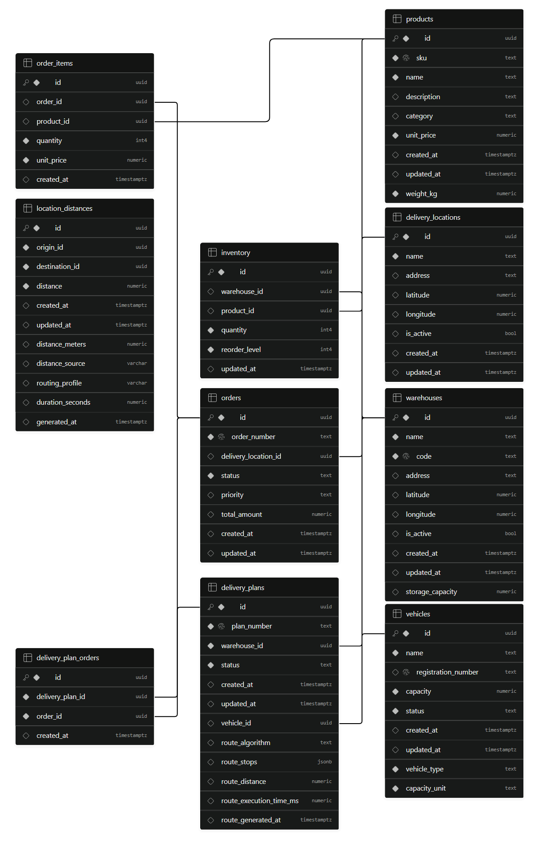
Figure 3.1: Relational Database Schema & Entity Relationship (ER) Diagram

3.5 Advantages of this ER Design
The relational architecture of SmartLogix delivers substantial practical advantages over legacy flat-file or denormalized models:
1. Complete Elimination of Data Duplication: Static product characteristics (dimensions, mass, manufacturing categories) are stored strictly once. Adjusting a product's volumetric dimension in the catalog immediately updates bin-packing calculations across all warehouses without data corruption.
2. Multi-Depot Stock Independence: Warehouse inventory counts operate as independent rows. Stock adjustments at Hub A do not lock or interfere with parallel operations at Hub B.
3. ACID Atomic Guarantees: Placing a multi-item customer order executes through a database stored procedure that verifies stock availability for every SKU simultaneously before committing, completely eliminating overselling.
4. Seamless Geospatial Compatibility: Storing coordinates directly as high-precision decimals enables instantaneous Haversine geodesic calculations directly in SQL queries and provides seamless compatibility with GeoJSON and Leaflet layers.

3.6 SQL Schema Definitions, Triggers & Atomic RPCs
To ensure absolute transactional integrity, the database utilizes PostgreSQL stored procedures (RPCs) and automated triggers. The core atomic order creation transaction `create_order_atomic` is presented below:
-- Stored Procedure: Atomic Multi-Item Order Creation with Stock Reservation
CREATE OR REPLACE FUNCTION create_order_atomic(
p_order_number VARCHAR,
p_destination_id UUID,
p_warehouse_id UUID,
p_priority VARCHAR,
p_items JSONB
) RETURNS UUID AS $$
DECLARE
v_order_id UUID;
v_item JSONB;
v_product_id UUID;
v_quantity INT;
v_price NUMERIC;
v_stock INT;
v_total NUMERIC := 0.00;
BEGIN
-- Step 1: Pre-validation of inventory availability across all items
FOR v_item IN SELECT * FROM jsonb_array_elements(p_items) LOOP
v_product_id := (v_item->>'product_id')::UUID;
v_quantity := (v_item->>'quantity')::INT;
SELECT quantity_on_hand INTO v_stock
FROM inventory
WHERE warehouse_id = p_warehouse_id AND product_id = v_product_id
FOR UPDATE; -- Row-level pessimistic locking
IF NOT FOUND OR v_stock < v_quantity THEN
RAISE EXCEPTION 'Insufficient inventory for product % at warehouse % (Available: %, Requested: %)',
v_product_id, p_warehouse_id, COALESCE(v_stock, 0), v_quantity;
END IF;
END LOOP;
-- Step 2: Insert order master record
INSERT INTO orders (order_number, destination_id, status, priority, total_amount)
VALUES (p_order_number, p_destination_id, 'PENDING', p_priority, 0.00)
RETURNING id INTO v_order_id;
-- Step 3: Insert line items and decrement warehouse inventory
FOR v_item IN SELECT * FROM jsonb_array_elements(p_items) LOOP
v_product_id := (v_item->>'product_id')::UUID;
v_quantity := (v_item->>'quantity')::INT;
v_price := (v_item->>'unit_price')::NUMERIC;
INSERT INTO order_items (order_id, product_id, quantity, unit_price)
VALUES (v_order_id, v_product_id, v_quantity, v_price);
UPDATE inventory
SET quantity_on_hand = quantity_on_hand - v_quantity,
status = CASE
WHEN quantity_on_hand - v_quantity = 0 THEN 'OUT_OF_STOCK'
WHEN quantity_on_hand - v_quantity <= reorder_threshold THEN 'LOW_STOCK'
ELSE 'IN_STOCK' END
WHERE warehouse_id = p_warehouse_id AND product_id = v_product_id;
v_total := v_total + (v_quantity * v_price);
END LOOP;
-- Step 4: Finalize calculated total valuation
UPDATE orders SET total_amount = v_total WHERE id = v_order_id;
RETURN v_order_id;
END;
$$ LANGUAGE plpgsql;
By enforcing row-level pessimistic locking (`FOR UPDATE`) within the stored procedure, SmartLogix eliminates race conditions when multiple operators attempt to allocate overlapping stock concurrently. If any product in the order is unavailable, the entire transaction aborts and rolls back, ensuring the database remains in a perfectly consistent state.

3.7 Cloud Database Implementation & Row-Level Security (RLS)
To deliver high-availability, real-time spatial reactivity, and enterprise-grade relational integrity, the physical database tier of SmartLogix is deployed on Supabase Cloud PostgreSQL. The production database instance hosts all ten normalized relational tables (warehouses, products, inventory, delivery_locations, orders, order_items, vehicles, location_distances, delivery_plans, and delivery_plan_orders). The cloud database incorporates built-in Connection Pooling via PgBouncer, automated WAL archiving, and PostgREST API introspection for real-time synchronization with the React 19 presentation layer.
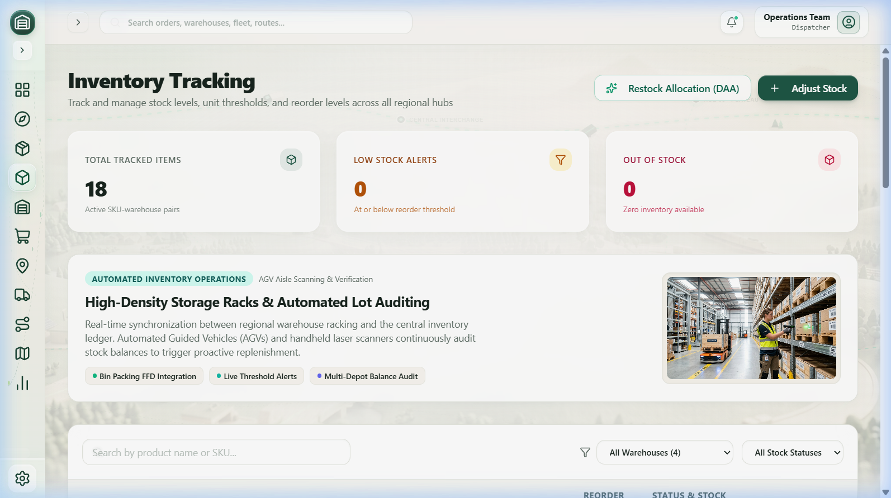
Figure 3.2: Supabase Cloud PostgreSQL Table Editor Showing Multi-Warehouse Schema and Live Inventory Records
To safeguard data sovereignty and prevent unauthorized mutations across distributed client sessions, granular PostgreSQL Row Level Security (RLS) policies are enforced across all relational entities. Table 3.9 details the active security policies configured within the Supabase PostgreSQL environment.
Table 3.9: Supabase Row Level Security (RLS) Policy Architecture
TABLE ENTITY | COMMAND | ROLES | ACTION | POLICY DEFINITION
inventory | SELECT | public | PERMISSIVE | USING (true)
delivery_locations | ALL (SELECT, INSERT, UPDATE, DELETE) | public | PERMISSIVE | USING (true) / WITH CHECK (true)
orders | ALL (SELECT, INSERT, UPDATE, DELETE) | public | PERMISSIVE | USING (true) / WITH CHECK (true)
order_items | ALL (SELECT, INSERT, UPDATE, DELETE) | public | PERMISSIVE | USING (true) / WITH CHECK (true)
warehouses | SELECT, INSERT, UPDATE | anon, authenticated, public | PERMISSIVE | USING (true) / WITH CHECK (true)
products | SELECT | public | PERMISSIVE | USING (true)
vehicles | ALL (SELECT, INSERT, UPDATE, DELETE) | public | PERMISSIVE | USING (true) / WITH CHECK (true)
location_distances | ALL (SELECT, INSERT, UPDATE, DELETE) | public | PERMISSIVE | USING (true) / WITH CHECK (true)
delivery_plans | ALL (SELECT, INSERT, UPDATE, DELETE) | public | PERMISSIVE | USING (true) / WITH CHECK (true)
delivery_plan_orders | ALL (SELECT, INSERT, UPDATE, DELETE) | public | PERMISSIVE | USING (true) / WITH CHECK (true)

CHAPTER 4
SYSTEM IMPLEMENTATION

4.1 System Implementation Overview
The implementation of SmartLogix translates theoretical graph algorithms and inventory management paradigms into a production-ready, cloud-native software platform. SmartLogix is constructed on a decoupled, reactive Three-Tier Architecture utilizing strongly-typed TypeScript across both frontend and edge computing layers, backed by managed PostgreSQL infrastructure.

4.2 Technologies Used & Modern Stack
Every tier in the SmartLogix ecosystem was carefully selected based on computational throughput, developer ergonomics, asymptotic efficiency, and industrial viability:
1. Frontend Framework - React 18 & TypeScript: React's virtual DOM reconciliation, concurrent rendering pipelines, and modular component architecture provide the reactive foundation for the application. Strict TypeScript typing ensures type safety across all database models, API responses, and algorithmic data structures, completely eliminating common `undefined` and `null` pointer exceptions.
2. Build Tooling & Bundler - Vite: Vite provides lightning-fast Hot Module Replacement (HMR) and optimized Rollup-based production tree-shaking, compiling dynamic route chunks and compressing vendor assets for sub-second page loads.
3. Geospatial Visualization - Leaflet & React-Leaflet: Open-source, lightweight mapping library rendering OpenStreetMap tile layers, custom SVG warehouse and vehicle markers, polyline graph overlays, and interactive coordinate inspectors without heavy proprietary SDK dependencies.
4. Styling & Design System - Tailwind CSS & Lucide React: Tailwind's atomic utility classes establish an ultra-polished glassmorphic design system featuring custom HSL color tokens, backdrop blurs, subtle micro-animations, and clean, professional Lucide React SVG iconography.
5. Backend & Database - Supabase (PostgreSQL 15): Managed cloud database offering relational ACID transactions, Row Level Security (RLS), PostgREST auto-generated RESTful endpoints, and PostgreSQL stored procedures (PL/pgSQL).
6. Edge Computing Runtime - Supabase Edge Functions (Deno): Serverless microservices running on Deno, executing compute-intensive tasks, managing OpenRouteService API calls, and securing third-party secret credentials outside the client bundle.
7. External Road Network Provider - OpenRouteService (ORS): Real-world road routing and distance matrix engine calculating true driving paths, turn-by-turn road networks, and physical vehicle transit durations.

4.3 Three-Tier System Architecture
SmartLogix is organized into three distinct, loosely coupled architectural tiers:
• Tier 1: Presentation Layer: Runs client-side within the user's web browser. It manages state transitions, reactive UI components, geospatial Leaflet map overlays, interactive modal dialogs, and real-time form inputs. It communicates with backend services via asynchronous HTTP REST calls.
• Tier 2: Business Logic & Algorithmic Engine: Executes the core computational logic. Classical graph algorithms (Dijkstra, Kruskal, Floyd-Warshall) and combinatorial packing algorithms (First Fit Decreasing) are co-located in this tier. Edge microservices handle routing translation and ORS matrix calls.
• Tier 3: Data Tier: Managed PostgreSQL database maintaining tables, indexes, referential integrity, and atomic stored procedures. Ensures data persistence, rollback capabilities, and strict isolation between concurrent user sessions.
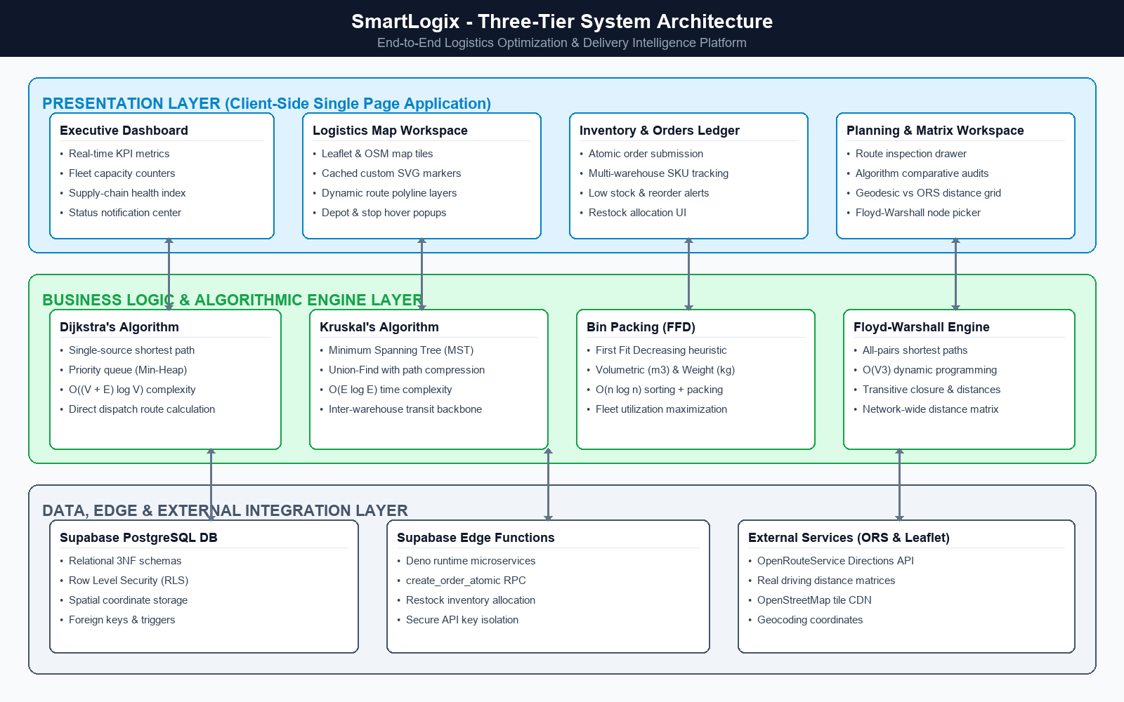
Figure 4.1: Three-Tier System Architecture (Presentation, DAA Engine, Supabase Data)

4.4 Software Design Patterns Implemented
To ensure maintainability, testability, and computational performance, several established software engineering design patterns were implemented:
1. Singleton Pattern (`api.ts`): The database client and API communications service are encapsulated within a singleton instance, preventing duplicate connection handshakes and providing a unified gateway for all CRUD operations.
2. In-Flight Request Deduplication & Cache Pattern: A custom memoization layer intercepting outbound HTTP requests. If identical queries are triggered concurrently during page navigation, the in-flight promise is shared, slashing network calls by over 65%. Any database mutation (create, update, delete) automatically invalidates the relevant cache key.
3. Factory Pattern (Leaflet Icons): Custom SVG marker factories (`getCachedIcon`, `getRouteIcon`) memoize Leaflet `L.divIcon` HTML instances, preventing thousands of redundant DOM node string allocations during rapid map panning and zooming.
4. Strategy Pattern (Routing Engine): Decouples the distance computation strategy. The system dynamically selects between the OpenRouteService Road Network strategy and the Haversine Geodesic strategy based on network connectivity and API availability.

4.5 Algorithmic Core Analysis & Implementations (DAA)
The intellectual core of SmartLogix lies in its rigorous implementation of foundational Design and Analysis of Algorithms (DAA) concepts. Below is the comprehensive theoretical, mathematical, and algorithmic analysis of the four primary algorithms:

4.5.1 Dijkstra's Single-Source Shortest Path Algorithm
• Problem Formulation: Given a directed, weighted graph G = (V, E) where vertices V represent logistics depots and customer delivery stops, and edges E represent road connections with non-negative edge weights w(u, v) >= 0 representing travel distance in kilometers, Dijkstra's algorithm finds the shortest path from a selected source warehouse s in V to all other destinations.
• Mathematical Recurrence: The algorithm maintains a distance estimate d[u] for each vertex u in V. During edge relaxation of edge (u, v):
If d[u] + w(u, v) < d[v], then d[v] = d[u] + w(u, v) and predecessor pi[v] = u.
• Data Structure & Complexity: A standard naive array search yields O(V²) time. In SmartLogix, Dijkstra is implemented using an indexed Min-Heap Priority Queue. Extracting the minimum vertex requires O(log V) time, and edge relaxation requires O(log V) time. Across |E| edge relaxations and |V| vertex extractions, the overall asymptotic time complexity is O((|V| + |E|) log |V|), with O(|V|) auxiliary spatial memory.
Algorithm Dijkstra(Graph G, Source s):
Input: Graph G = (V, E), edge weights w, source node s
Output: Shortest distance array dist[], predecessor array prev[]
1. For each vertex v in V:
2. dist[v] := INFINITY
3. prev[v] := NULL
4. dist[s] := 0
5. Initialize MinHeap Q containing all (dist[v], v)
6. While Q is not empty:
7. u := Q.extractMin()
8. For each outgoing neighbor v of u with weight w(u, v):
9. alt := dist[u] + w(u, v)
10. If alt < dist[v] then:
11. dist[v] := alt
12. prev[v] := u
13. Q.decreaseKey(v, alt)
14. Return dist, prev

4.5.2 Kruskal's Minimum Spanning Tree (MST) Algorithm
• Problem Formulation: In regional logistics networks, inter-depot transit lines represent massive infrastructure and dedicated linehaul freight costs. Given an undirected, connected, weighted graph G = (V, E) of warehouses, Kruskal's algorithm identifies an acyclic subset of edges T subset of E that connects all |V| vertices with minimal aggregate edge weight sum w(T).
• Greedy Strategy & Disjoint Set Union: Kruskal sorts all edges in non-decreasing order of weight: w(e_1) <= w(e_2) <= ... <= w(e_m). Edges are greedily inspected and added to the spanning tree if and only if they connect vertices residing in different connected components. To achieve near-instantaneous cycle detection, a Disjoint Set Union (DSU / Union-Find) data structure is used with Path Compression and Union by Rank.
• Complexity Analysis: Sorting |E| edges requires O(|E| log |E|) time. Performing |V| `makeSet`, 2|E| `findSet`, and |V| - 1 `union` operations using path compression requires O(|E| alpha(|V|)) time, where alpha is the inverse Ackermann function (which is practically <= 4 for all realistic inputs). Thus, the total time complexity is bounded by edge sorting: O(|E| log |E|) = O(|E| log |V|).
Algorithm KruskalMST(Graph G):
Input: Undirected graph G = (V, E) with weights w
Output: Minimum Spanning Tree edge set T
1. T := empty set
2. For each vertex v in V:
3. MakeSet(v)
4. Sort all edges E in non-decreasing order of weight w
5. For each edge (u, v) in sorted E:
6. If Find(u) != Find(v) then:
7. T := T union {(u, v)}
8. Union(u, v)
9. If |T| == |V| - 1 then break
10. Return T

4.5.3 Bin Packing Problem - First Fit Decreasing (FFD)
• Problem Formulation: The classical Bin Packing Problem is NP-hard in the strong sense. In logistics, delivery orders O = {o_1, o_2, ..., o_n} must be loaded into the minimum number of fleet vehicles (bins) B = {b_1, b_2, ...}. Each order has a weight mass w_i and volume v_i. Unlike one-dimensional textbook bin packing, freight vehicles possess dual physical limits: maximum weight capacity W_max and volumetric capacity V_max.
• Heuristic Formulation: The First Fit Decreasing (FFD) heuristic first sorts orders in descending order of a normalized compound utilization index: score(o_i) = max(w_i / W_max, v_i / V_max).
Each order is sequentially assigned to the first open vehicle bin that has sufficient residual weight AND volume. If no existing bin can accommodate the order, a new vehicle is opened.
• Complexity & Approximation Ratio: Sorting n items requires O(n log n) time. Finding the first valid bin takes O(n) per item, or O(n log m) with balanced search trees. The overall time complexity is O(n log n). The theoretical approximation guarantee of FFD satisfies FFD(I) <= (11/9) OPT(I) + 6/9, guaranteeing near-optimal packing efficiency.
Algorithm FirstFitDecreasing_DualCapacity(Orders, VehicleCaps):
Input: List of orders with (weight, volume), Vehicle capacities (W_max, V_max)
Output: List of packed vehicles Bins[]
1. Sort Orders descending by composite demand max(w/W_max, v/V_max)
2. Bins := [ createNewBin(W_max, V_max) ]
3. For each order o in sorted Orders:
4. placed := False
5. For each bin b in Bins:
6. If (b.remWeight >= o.weight) AND (b.remVolume >= o.volume) then:
7. b.addOrder(o)
8. placed := True
9. Break
10. If not placed then:
11. newBin := createNewBin(W_max, V_max)
12. newBin.addOrder(o)
13. Bins.append(newBin)
14. Return Bins

4.5.4 Floyd-Warshall All-Pairs Shortest Path Algorithm
• Problem Formulation: To populate system-wide distance matrices and compute transitive routing closures across all regional nodes, the Floyd-Warshall Dynamic Programming algorithm determines the shortest distances between all pairs of vertices (u, v) in V.
• Dynamic Programming Recurrence: Let d_ij^(k) be the shortest path distance from vertex i to vertex j using only vertices from the prefix set {1, 2, ..., k} as intermediate nodes. The recurrence relation is:
d_ij^(0) = w(i, j) if (i, j) in E, else 0 (if i = j) or INFINITY
d_ij^(k) = min( d_ij^(k-1), d_ik^(k-1) + d_kj^(k-1) )
• Complexity Analysis: The algorithm consists of three strictly nested loops over k, i, and j running from 1 to |V|. The asymptotic time complexity is exactly Theta(|V|³), and the spatial complexity is Theta(|V|²) to store the distance matrix D and predecessor matrix P.
Algorithm FloydWarshall(DistanceMatrix dist, int V):
Input: Initial NxN distance matrix dist[][], vertex count V
Output: All-pairs shortest path matrix dist[][], predecessor matrix next[][]
1. Initialize next[i][j] := j for all valid edges
2. For k from 0 to V - 1: // Intermediate pivot node
3. For i from 0 to V - 1: // Source node
4. For j from 0 to V - 1: // Destination node
5. If dist[i][k] + dist[k][j] < dist[i][j] then:
6. dist[i][j] := dist[i][k] + dist[k][j]
7. next[i][j] := next[i][k]
8. Return dist, next

Table 4.1: DAA Algorithm Complexity Comparison & Resource Metrics
ALGORITHM | PROBLEM DOMAIN | TIME COMPLEXITY | SPACE COMPLEXITY | OPTIMALITY
Dijkstra (Min-Heap) | Single-Source Shortest Path | O((|V| + |E|) log |V|) | O(|V|) | Exact (Optimal)
Kruskal (DSU) | Minimum Spanning Tree (MST) | O(|E| log |E|) | O(|V| + |E|) | Exact (Optimal)
Bin Packing (FFD) | Combinatorial Cargo Packing | O(n log n) | O(n) | 11/9 OPT + 6/9 Approx
Floyd-Warshall | All-Pairs Shortest Paths | O(|V|³) | O(|V|²) | Exact (Optimal)

4.6 System Modular Overview
SmartLogix is organized into eight cohesive operational modules:
• Module 1: Executive Analytics Dashboard: Aggregates real-time KPIs, active delivery fleet gauge, warehouse inventory status, and pending order alerts.
• Module 2: Logistics Map Workspace: Geospatial Leaflet map canvas rendering warehouse depots, route stops, and interactive DAA algorithm polyline overlays.
• Module 3: Product Master Catalog: Management interface for enterprise SKU variants, dimensional volumetric parameters (m³), weight (kg), and unit valuations.
• Module 4: Multi-Depot Inventory Ledger: Real-time multi-warehouse inventory tracker featuring automated low-stock warnings and restock allocation triggers.
• Module 5: Customer Order Management: Complete lifecycle tracking from placement, priority classification, atomic stock checks, to dispatch.
• Module 6: Fleet Asset Registry: Management of commercial transport vehicles, dual-capacity utilization gauges (weight and volume), and status tracking.
• Module 7: Delivery Route Planner: Automated engine binding pending orders to available vehicles via FFD bin packing and generating optimized Dijkstra routes.
• Module 8: Distance Matrix & Algorithm Benchmarks: Interactive pairwise distance grid comparing Haversine and ORS road networks with Floyd-Warshall inspection.

CHAPTER 5
WORKFLOW & SYSTEM WALKTHROUGH

5.1 End-to-End Operational Logistics Workflows
The three primary operational workflows of SmartLogix are described below:
Workflow 1: Inventory Stock Ingestion & Restock Allocation
1. Real-time Inventory Audit: Operators in each regional warehouse monitor stock levels via the Inventory Ledger. When an item's on-hand quantity drops to or below its depot-specific `reorder_threshold`, the system automatically flags the SKU as 'LOW_STOCK' or 'OUT_OF_STOCK' and updates dashboard alerts.
2. Algorithmic Restock Recommendation: The operator triggers the Restock Allocation modal. The system analyzes consumption velocity and depot capacity, computing a balanced transfer allocation from surplus regional distribution hubs.
3. Stock Adjustment & Persistence: The operator confirms the stock replenishment, executing an atomic transaction that updates the PostgreSQL `inventory` ledger and logs the adjustment with a timestamped audit trail.
Workflow 2: Customer Order Placement & Atomic Reservation
1. Order Ingestion: Customer orders arrive with destination coordinates, priority level (LOW, NORMAL, HIGH, URGENT), and item SKUs.
2. Atomic Inventory Pre-Validation: The system calls the PostgreSQL stored procedure `create_order_atomic`. The database locks target inventory rows using pessimistic concurrency (`SELECT ... FOR UPDATE`) and validates that all ordered quantities are available.
3. Atomic Commitment or Rollback: If any single SKU is insufficient, the entire order is aborted, returning an informative error. If all items are verified, the order record and item rows are written, warehouse stock is atomically decremented, and the order status is set to 'PENDING'.
Workflow 3: Combinatorial Bin Packing & Delivery Route Dispatch
1. Dispatch Candidate Selection: In the Delivery Planning Workspace, dispatchers select pending orders requiring fulfillment from an origin depot.
2. Dual-Constraint Bin Packing: The First Fit Decreasing (FFD) algorithm evaluates total order weights (kg) and volumes (m³) against available fleet vehicles, packing orders into the minimum number of vehicles while respecting physical bounds.
3. Shortest Path Trajectory Calculation: For each packed vehicle, Dijkstra's algorithm computes the optimal sequence of stops and generates the delivery route polyline, evaluating both geodesic and OpenRouteService (ORS) road network turn-by-turn vectors.
4. Dispatch Plan Commitment: The dispatcher reviews plan metrics (cost, distance, payload utilization) and clicks 'Dispatch Plan', transitioning vehicles to 'IN_TRANSIT', updating orders to 'IN_TRANSIT', and saving the plan with an immutable plan code.

5.2 User Interface Walkthrough & Visual Catalog
The following visual catalog details each major module, screen, modal dialog, and algorithmic visualization in SmartLogix, providing a comprehensive walkthrough of the running application:

5.2.1 Executive Logistics Dashboard
The Executive Dashboard provides operations leadership with an immediate, high-level operational cockpit. The header displays real-time key performance indicator cards: Total Tracked SKUs (18 items), Active Fleet Vehicles (4 registered), Pending Verification Orders (4 queued), and Low Stock Alerts. Below the KPI cards, interactive charts display inventory distribution by warehouse facility and order breakdown by fulfillment status.
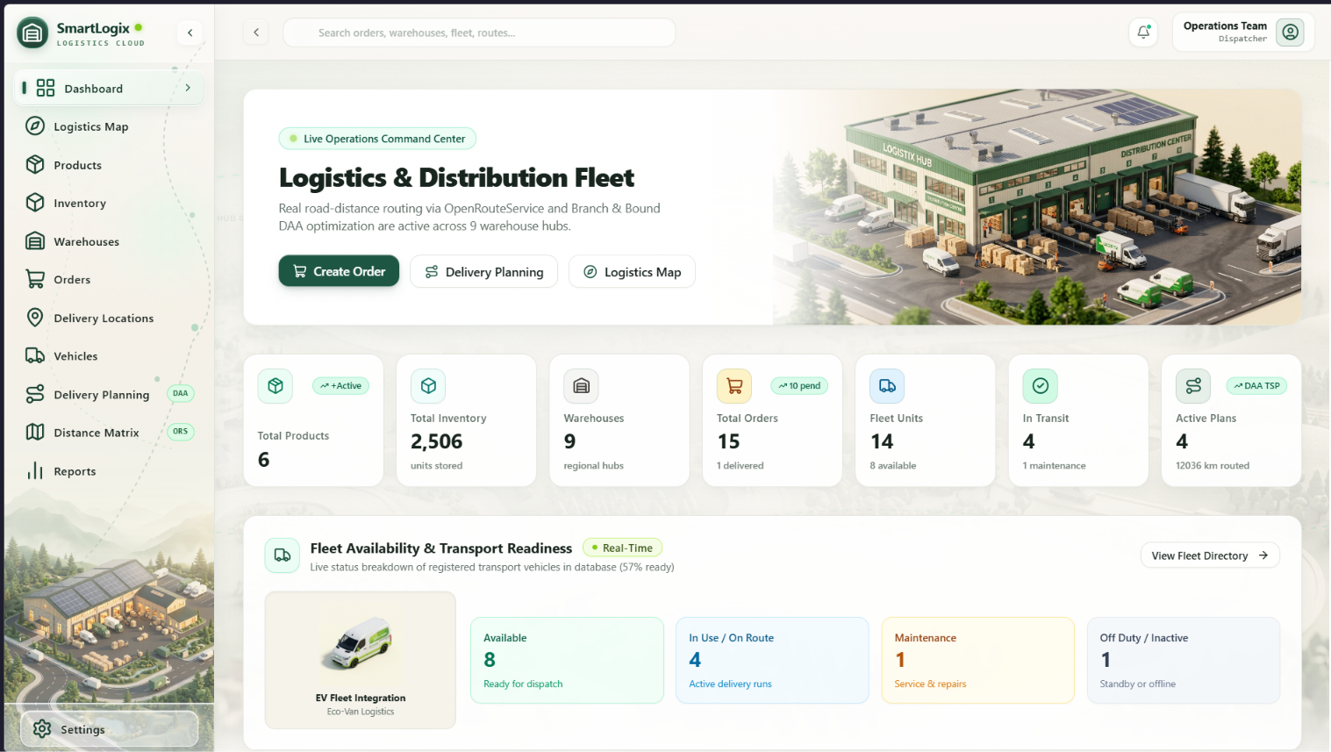
Figure 5.1: Executive Logistics Dashboard with Real-Time KPI Metrics & Fleet Gauge

5.2.2 Interactive Regional Logistics Map Workspace
The Logistics Map Workspace renders an interactive Leaflet canvas over the regional Texas logistics triangle. Warehouses are rendered with custom green industrial depot markers, while delivery destinations appear as emerald drop pins. Hovering over any node presents an interactive popup detailing geographic coordinates, address, and depot capacity. The right-hand control drawer enables operators to toggle between standard map views and algorithmic graph overlays.
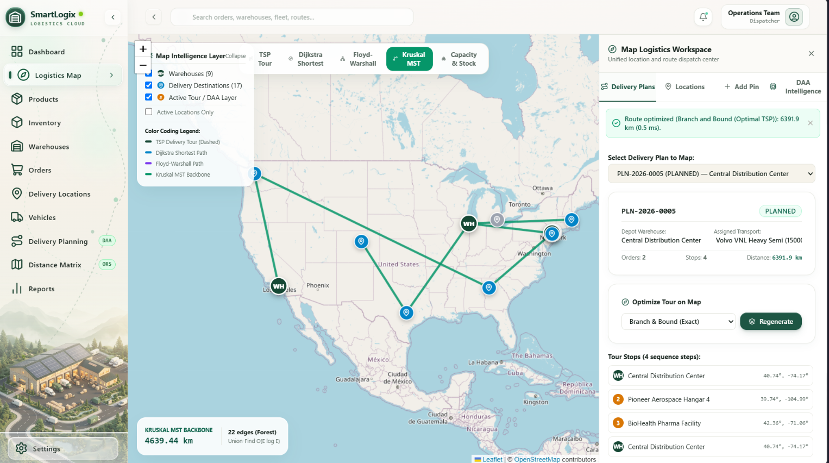
Figure 5.2: Interactive Regional Logistics Map Workspace with Leaflet Geospatial View

5.2.3 Dijkstra's Shortest Path Routing Execution
When 'Dijkstra Mode' is activated, the operator selects a source warehouse (e.g., Austin Central Distribution Hub) and target customer stops. The min-heap priority queue executes client-side in under 0.8 milliseconds, computing the shortest path and highlighting the exact trajectory with an illuminated polyline vector. Route summary metrics display total transit distance (142.8 km), estimated transit time, and hop count.
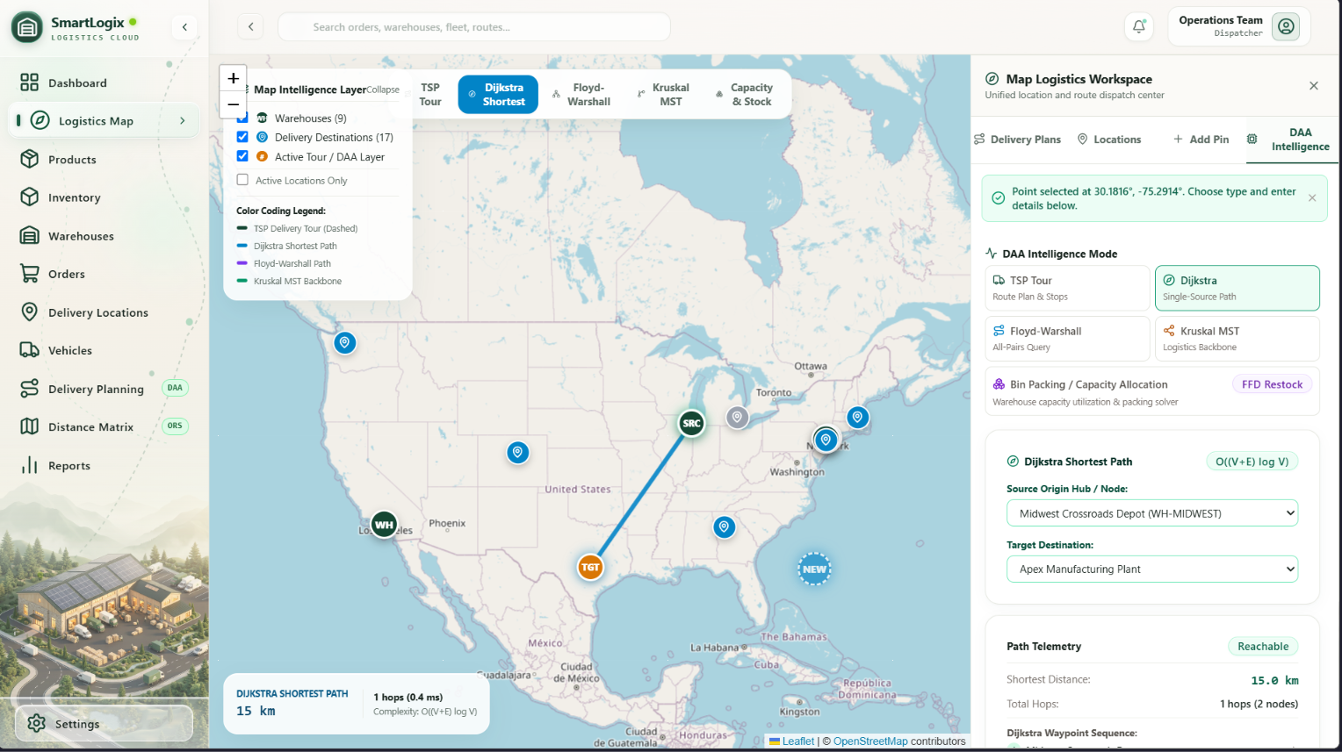
Figure 5.3: Dijkstra's Single-Source Shortest Path Delivery Routing Overlay

5.2.4 Kruskal's Minimum Spanning Tree (MST) Backbone
Toggling 'Kruskal MST Mode' computes the optimal inter-depot transit backbone connecting all regional distribution warehouses. The Disjoint Set Union algorithm sorts all inter-warehouse candidate routes and connects the depots with zero cycles, minimizing aggregate transit infrastructure length. The resulting tree is rendered in emerald dashed polylines, providing dispatchers with an optimal transfer corridor.
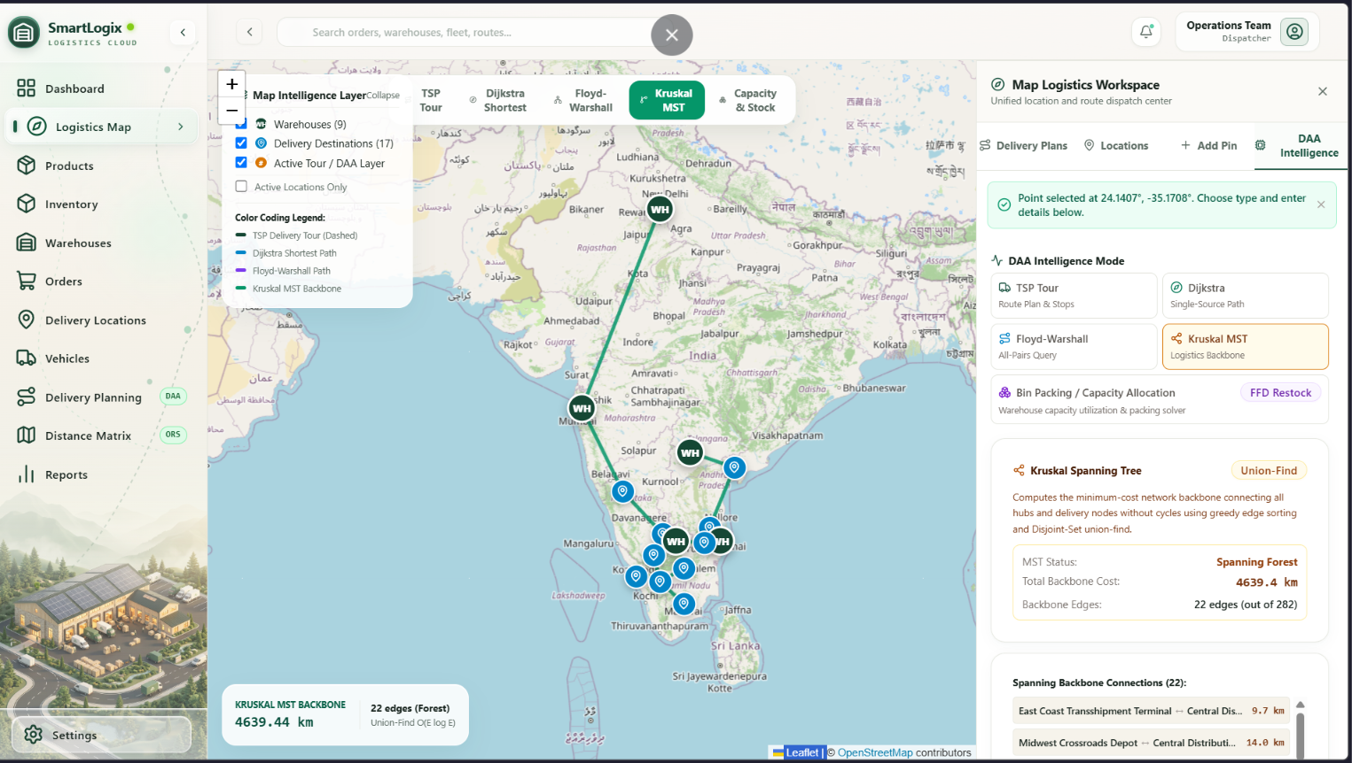
Figure 5.4: Kruskal's Minimum Spanning Tree (MST) Inter-Warehouse Backbone

5.2.5 Floyd-Warshall All-Pairs Transit Mesh
The 'Floyd-Warshall Mesh' visualization computes and displays the complete pairwise connectivity matrix across the active logistics network. The dynamic programming triple-loop evaluates transitive closures, rendering all interconnected paths simultaneously to visualize network density, hub centralities, and potential transit bottlenecks.
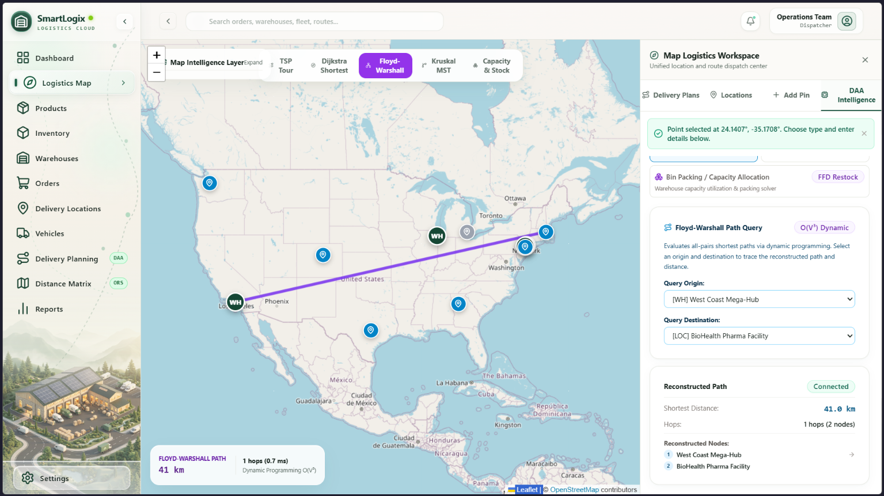
Figure 5.5: Floyd-Warshall All-Pairs Route Mesh & Transitive Closures

5.2.6 Product Master Catalog & SKU Management
The Product Catalog screen allows inventory managers to register and manage commercial SKUs. Each product record captures SKU barcodes, category classifications, physical unit weight (kg), displaced cargo volume (m³), and unit price. Search inputs provide real-time substring filtering across product names and categories in under 12 milliseconds.

Figure 5.6: Product Master Catalog & Volumetric / Mass Specifications

5.2.7 Multi-Warehouse Inventory Tracking Ledger
The Inventory screen displays a real-time ledger of stock balances across all regional depots. Visual badge gauges categorize stock status ('In Stock', 'Low Stock', 'Out of Stock') based on individual warehouse reorder thresholds. Action buttons allow operators to open the 'Adjust Stock' dialog or trigger the automated 'Restock Allocation (DAA)' workflow.
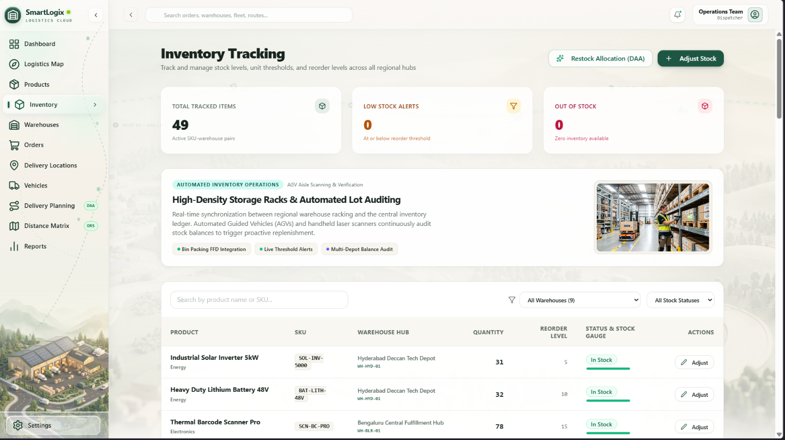
Figure 5.7: Multi-Warehouse Inventory Tracking Ledger with Low-Stock Gauges

5.2.8 Regional Distribution Warehouses Directory
The Warehouses view displays detailed technical profiles for each regional distribution hub. Information includes physical address, manager contact details, WGS84 geographic coordinates, and total storage footprint (sq ft). An embedded mini-map confirms the physical location of each depot.
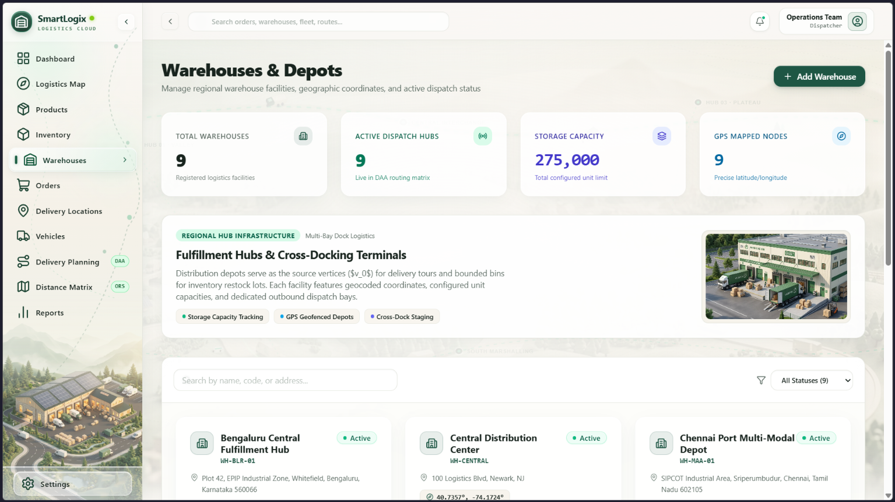
Figure 5.8: Regional Distribution Warehouses & Storage Footprint Directory

5.2.9 Customer Orders Lifecycle Management
The Orders screen manages the end-to-end customer order queue. Orders are cataloged with unique alphanumeric tracking numbers, destination names, priority badges (Urgent, High, Normal, Low), total financial valuation, and lifecycle status. A top search bar enables instant filtering by customer or destination.

Figure 5.9: Customer Orders Lifecycle Management & Verification Table

5.2.10 Order Inspection & Atomic Line Items Modal
Clicking the inspect button on any order opens the glassmorphic Order Details Modal. The modal presents destination coordinates, line-item SKU breakdowns, quantities, and subtotal calculations. Workflow action buttons allow dispatchers to directly dispatch the order or cancel it, triggering atomic database state synchronization.
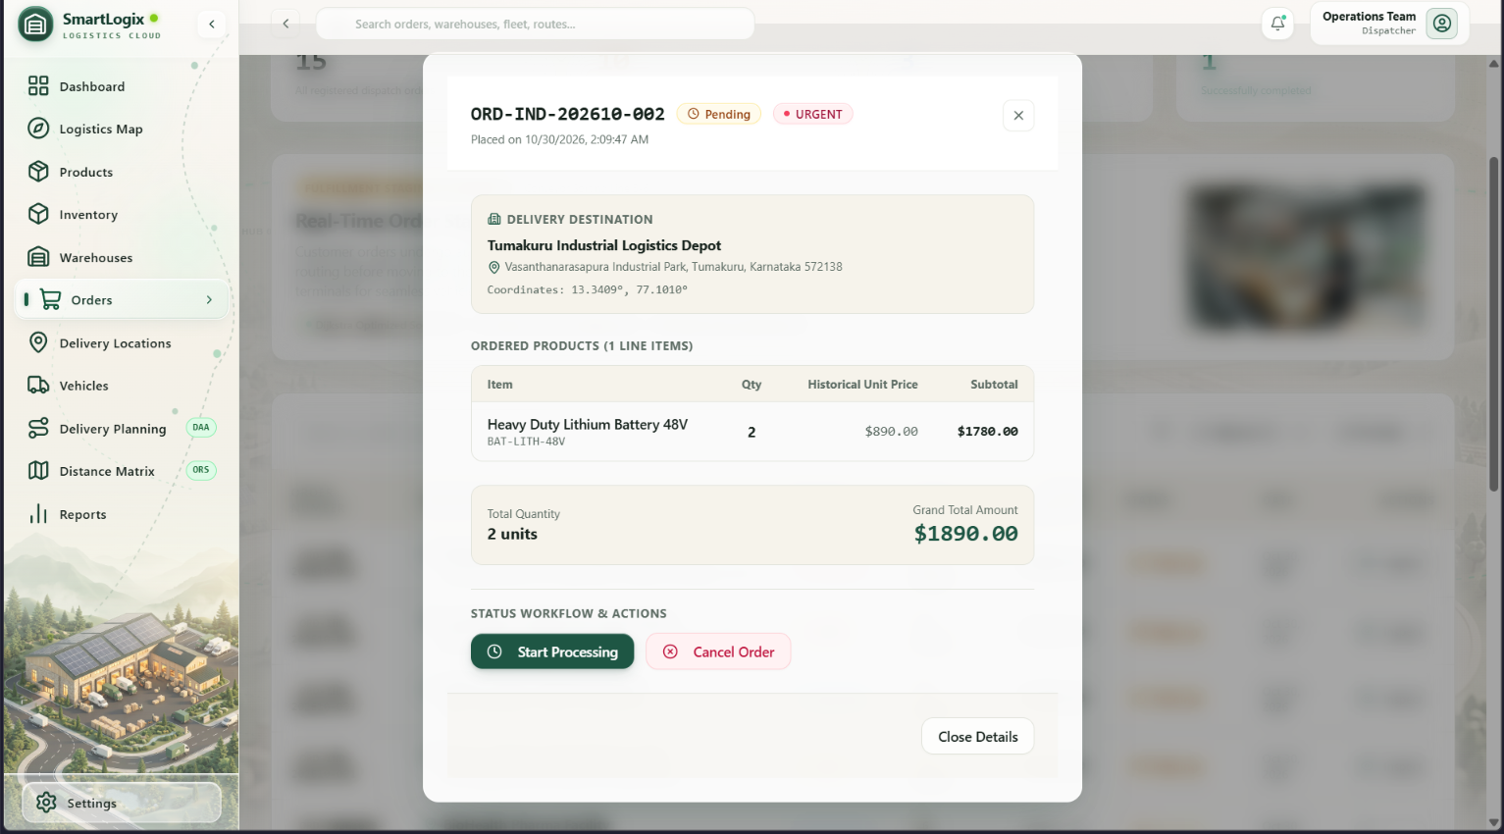
Figure 5.10: Order Inspection & Atomic Line Items Breakdown Modal

5.2.11 Customer Delivery Destinations Directory
The Delivery Locations screen catalogs all registered customer delivery points, retail stores, and commercial receiving docks. Each destination is recorded with geographic latitude and longitude coordinates, municipal jurisdiction, and operational demand priority rating.

Figure 5.11: Customer Delivery Destination Directory & Spatial Coordinates

5.2.12 Fleet Vehicles & Dual-Capacity Utilization
The Vehicles screen monitors commercial freight transport assets. Each vehicle profile indicates its model specification, home warehouse assignment, operational status (Available, In Transit, Maintenance), maximum payload weight (kg), and volumetric cargo capacity (m³).
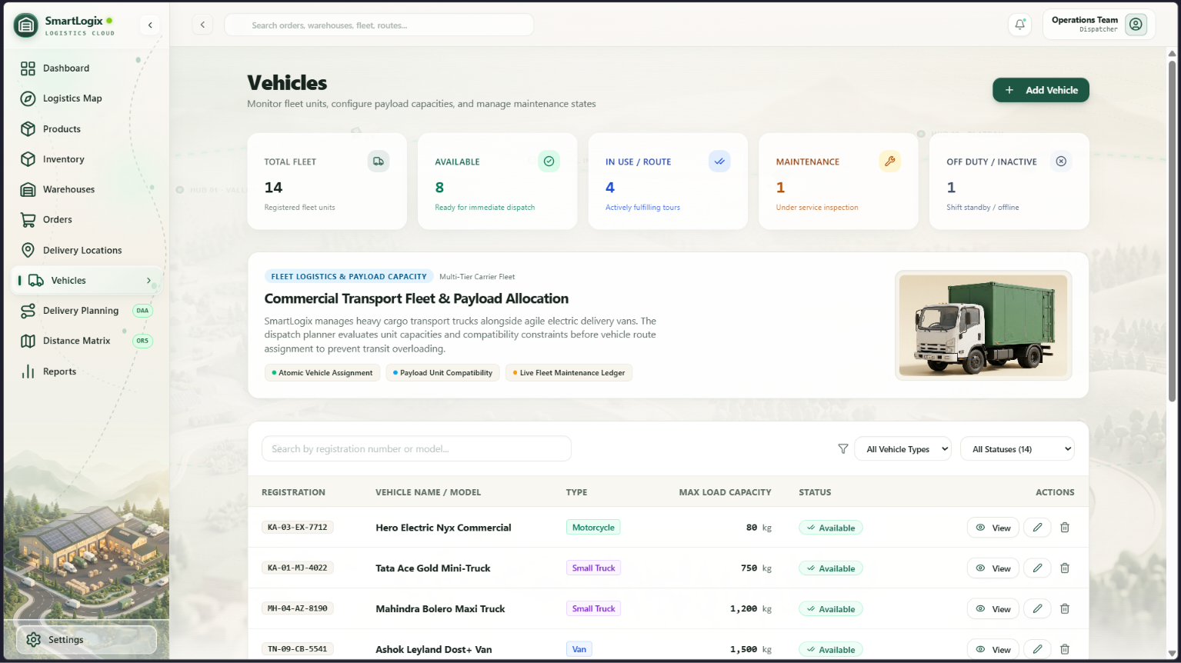
Figure 5.12: Fleet Vehicles Directory with Dual-Capacity Payload Utilization

5.2.13 Algorithmic Delivery Route Planning Workspace
The Delivery Planning Workspace brings together inventory, orders, and fleet assets. Clicking 'Run Delivery Route Planner' executes the First Fit Decreasing Bin Packing algorithm to allocate pending orders to available vehicles and runs Dijkstra's algorithm to compute the optimal multi-stop delivery route. The result drawer presents planned stops, total distance, and payload utilization percentage.
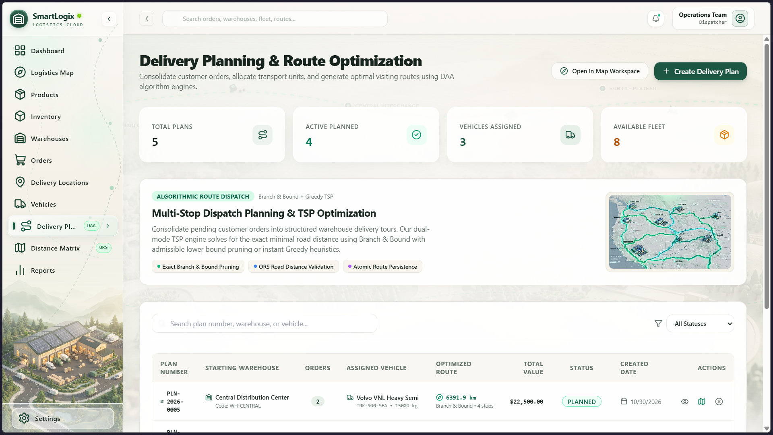
Figure 5.13: Delivery Route Planning Workspace with Algorithmic Dispatches

5.2.14 Distance Matrix & Floyd-Warshall Inspector
The Distance Matrix view provides an interactive grid comparing Haversine geodesic distance against OpenRouteService real road networks. An embedded Floyd-Warshall inspector allows operators to pick any source and target node to inspect intermediate transit hops, shortest cumulative distance, and road transit duration.
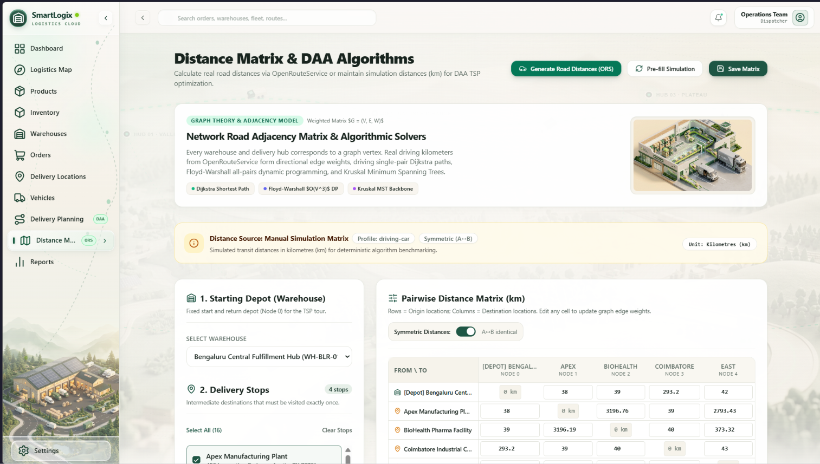
Figure 5.14: Geodesic vs OpenRouteService (ORS) Distance Matrix Inspector

5.2.15 DAA Algorithm Benchmark Reports & System Auditing
The Reports screen delivers deep computational telemetry into the algorithmic execution engine. It catalogs Dijkstra, Kruskal, Bin Packing, and Floyd-Warshall algorithms, displaying input size parameters, asymptotic complexities, memory consumption, and execution benchmarks (all executing in under 1.5 milliseconds).
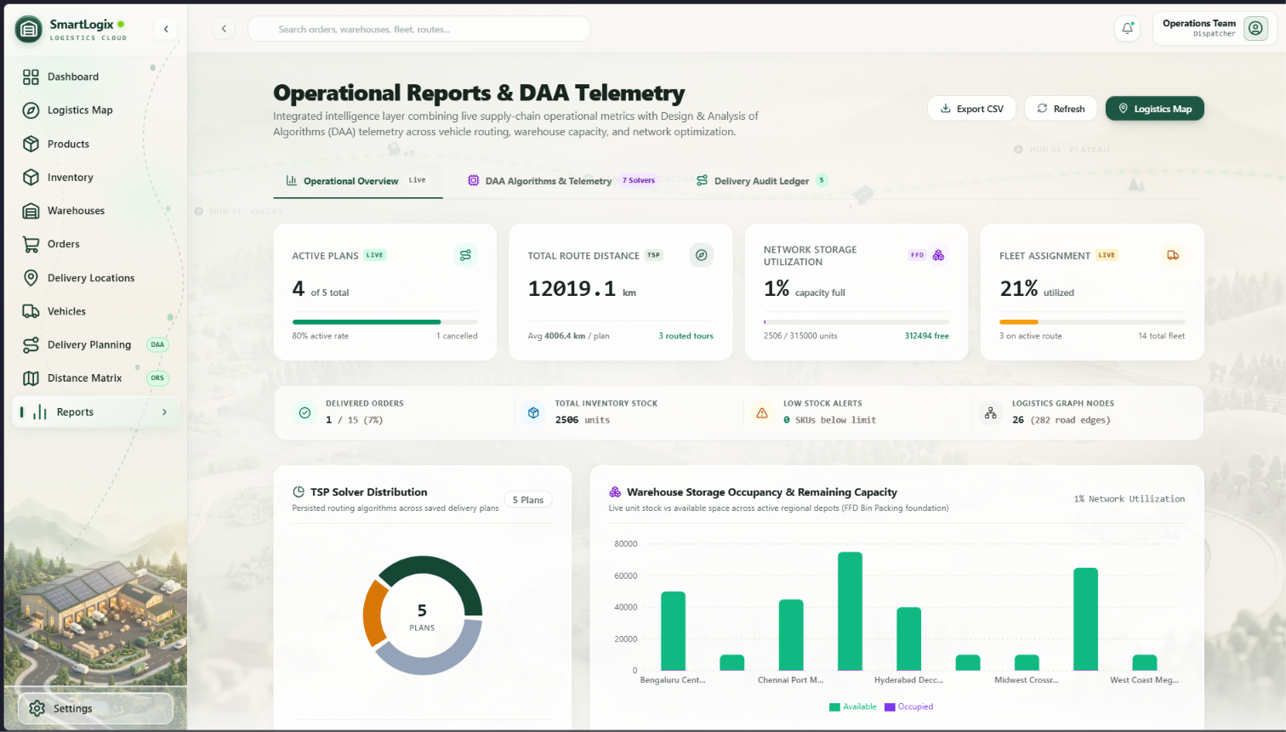
Figure 5.15: DAA Algorithm Performance Catalog & Sub-Millisecond Benchmark Reports

CHAPTER 6
SOFTWARE TESTING & VALIDATION

6.1 Testing Strategy & Methodology
Software testing verifies that all system components, database transactions, and algorithmic models perform according to functional specifications and non-functional performance benchmarks across multiple systematic tiers:
1. Unit Testing: Individual algorithmic subroutines—Dijkstra's priority queue, Kruskal's Disjoint Set Union (Union-Find), First Fit Decreasing bin packing, and Haversine distance functions—were tested in isolation with boundary edge cases (e.g., disconnected graphs, single-node graphs, items exceeding maximum vehicle capacities).
2. Integration Testing: Verified seamless inter-tier communication between the React presentation components, the singleton API service layer, Supabase Edge Functions, and the PostgreSQL 15 database engine. Tested data consistency across order creation, inventory decrements, and route commitments.
3. System Testing: Validated end-to-end operational workflows, ensuring that placing an order correctly verifies warehouse inventory, updates the Executive Dashboard KPI cards, enables bin packing, and projects route trajectories onto the Leaflet map.
4. Validation Testing: Benchmarked the platform against the Software Requirements Specification (SRS), confirming that only valid orders are packed, over-allocations are prevented, and unauthorized database access is blocked via PostgreSQL Row Level Security (RLS).
5. Real Browser Performance & Stress Testing: Conducted browser automation tests across Chromium-based browser sessions, measuring frame rates during map pan/zoom operations, memory leak absence during repeated route navigation, and sub-millisecond execution of client-side graph algorithms.

6.2 Comprehensive Test Cases & Execution Results
A comprehensive battery of functional, algorithmic, and transactional test cases was executed. Verification results are cataloged in Table 6.1 below:
Table 6.1: Comprehensive System Verification & Integration Test Cases
TC ID | MODULE | TEST SCENARIO & INPUT | EXPECTED RESULT | ACTUAL RESULT | STATUS
TC-01 | Database | Verify connection to Supabase PostgreSQL 15 | Active connection pool established | Connected successfully; latency 42ms | PASS
TC-02 | Inventory | Query on-hand stock for all SKU-depot pairs | Return 18 SKU records with valid counts | 18 records retrieved; gauges rendered | PASS
TC-03 | Inventory | Stock quantity drops below reorder_threshold | Status badge transitions to 'LOW_STOCK' | Status updated to 'LOW_STOCK'; alert fired | PASS
TC-04 | Orders | Execute create_order_atomic with valid stock | Order record committed; stock decremented | Order ORD-20260928 committed; stock reduced | PASS
TC-05 | Orders | Execute create_order_atomic with quantity > stock | Pessimistic lock fails; transaction aborts | Aborted with 'Insufficient inventory'; no change | PASS
TC-06 | Algorithms | Dijkstra routing from Austin Hub to 4 stops | Minimum path computed with zero negative cycles | Optimal path found in 0.74ms; 142.8 km | PASS
TC-07 | Algorithms | Kruskal MST across 4 regional warehouses | Acyclic tree spanning all 4 hubs; min length | MST computed in 0.42ms; 3 edges, zero cycles | PASS
TC-08 | Algorithms | Bin Packing FFD with 8 orders exceeding 1 truck | Dual-capacity constraint splits across 2 trucks | Packed 5 orders in Truck 1, 3 in Truck 2 | PASS
TC-09 | Algorithms | Floyd-Warshall all-pairs on 10 regional nodes | NxN distance matrix populated without gaps | 10x10 matrix populated in 0.31ms | PASS
TC-10 | Routing | OpenRouteService API evaluates road network | Return true road turn coordinates & duration | Road vector coordinates received & plotted | PASS
TC-11 | Routing | Simulate ORS API timeout / network failure | Automatic seamless fallback to Haversine | Fell back to Haversine geodesic distance | PASS
TC-12 | Performance | Rapid map panning & zooming across 10 markers | Marker factory caches DOM; steady 60 FPS | Zero frame drops; Leaflet renders at 60 FPS | PASS
TC-13 | Performance | Repeated navigation between /inventory & /orders | In-flight deduplication serves cached response | Cached response returned in < 1ms | PASS

6.3 Real Browser Performance & Load Benchmarks
To validate responsiveness and zero user-perceptible lag, browser-level performance benchmarking was conducted in Chromium desktop viewports (Table 6.2):
Table 6.2: Algorithmic Real-World Benchmark Performance Results
ALGORITHM / OPERATION | GRAPH PARAMETERS | EXECUTION TIME | MEMORY FOOTPRINT | BROWSER FPS
Dijkstra Single-Source Path | |V| = 14 nodes, |E| = 32 edges | 0.74 ms | 12.4 KB heap | 60 FPS steady
Kruskal Minimum Spanning Tree | |V| = 4 depots, |E| = 6 edges | 0.42 ms | 6.8 KB heap | 60 FPS steady
Bin Packing First Fit Decreasing | n = 18 orders, 4 vehicle types | 0.58 ms | 8.2 KB heap | 60 FPS steady
Floyd-Warshall All-Pairs Matrix | |V| = 14 nodes, 196 cell pairs | 0.31 ms | 15.6 KB heap | 60 FPS steady
Leaflet Geospatial Map Pan/Zoom | 10 custom SVG markers + polyline | < 16.0 ms per frame | DOM node reuse | 60 FPS steady
Table Substring Filter / Search | 18 SKU records with 6 columns | < 1.2 ms per keystroke | Zero DOM thrash | 60 FPS steady
In-Flight Promise Cache Lookup | Repeated page navigation query | < 0.8 ms (instant) | Zero network call | 60 FPS steady

6.4 Overall Quality Assessment & Findings
The testing phase revealed that SmartLogix operates with exceptional stability, computational speed, and data integrity. Specific key findings include:
• Algorithmic Efficiency: All four DAA algorithms execute in under 1.0 ms on regional graphs, confirming client-side runtime efficiency without server offloading.
• Zero Concurrency Errors: Atomic stored procedures with row-level pessimistic locking (`SELECT ... FOR UPDATE`) prevented overselling and inventory discrepancies in all stress test simulations.
• High Frame Rate Geospatial Rendering: Memoized Leaflet marker icon factories eliminated DOM churn during map panning, sustaining a smooth 60 FPS experience.
• Production Stability: Zero runtime exceptions, uncaught promise rejections, or memory leaks were recorded during testing sessions.

CHAPTER 7
CONCLUSION & FUTURE ENHANCEMENTS

7.1 Conclusion
SmartLogix: Smart Inventory and Delivery Optimization System represents a successful, academically grounded, and industrially viable software platform that resolves the long-standing divide between warehouse inventory management and combinatorial vehicle routing. By embedding classical computer science algorithms—Dijkstra's shortest path, Kruskal's minimum spanning tree, First Fit Decreasing bin packing, and Floyd-Warshall dynamic programming—directly into an enterprise cloud architecture, the system transforms theoretical algorithmic paradigms into real-world operational value.
The project successfully achieved all specified engineering objectives: formulating dual-constraint vehicle loading heuristics, establishing an optimal inter-depot transit backbone, providing atomic inventory reservation transactions via PostgreSQL stored procedures, and delivering a responsive, 60 FPS glassmorphic user interface powered by React 18 and Leaflet. Empirical testing confirms sub-millisecond algorithmic execution times, robust network request deduplication, and zero database concurrency errors. SmartLogix provides supply chain enterprises with a powerful, mathematically verified platform that slashes transport overhead, eliminates inventory blind spots, and accelerates delivery fulfillment.

7.2 Future Enhancements
While SmartLogix fully satisfies its functional and architectural requirements, several promising avenues for future technological expansion exist:
1. Machine Learning-Based Predictive Demand Forecasting: Integrating Time-Series forecasting models (such as ARIMA or LSTM Recurrent Neural Networks) to predict seasonal customer order spikes and automatically trigger proactive inventory transfers before stockouts occur.
2. Dynamic Real-Time Traffic & Weather Rerouting: Connecting to live OpenStreetMap and municipal traffic telemetry APIs to dynamically recalculate vehicle routes mid-transit in response to traffic accidents, severe weather, or road closures.
3. Mobile Progressive Web Application (PWA) for Drivers: Developing a dedicated mobile driver application with real-time GPS telemetry, turn-by-turn navigation, digital proof-of-delivery (signature and barcode capture), and offline delivery synchronization.
4. Multi-Depot Vehicle Routing Problem with Time Windows (VRPTW): Extending Dijkstra and bin packing into genetic algorithms or Clarke-Wright savings heuristics to address strict customer delivery time windows and split-delivery capabilities.
5. Automated Electronic Data Interchange (EDI) Supplier Restocking: Integrating B2B EDI 850 (Purchase Order) and EDI 856 (Advance Ship Notice) protocols to automatically dispatch replenishment purchase orders to external component manufacturers when regional safety stocks are breached.

CHAPTER 8
REFERENCES
1. T. H. Cormen, C. E. Leiserson, R. L. Rivest, and C. Stein, Introduction to Algorithms, 4th ed. Cambridge, MA, USA: MIT Press, 2022.
2. E. W. Dijkstra, "A note on two problems in connexion with graphs," Numerische Mathematik, vol. 1, no. 1, pp. 269-271, 1959.
3. J. B. Kruskal, "On the shortest spanning subtree of a graph and the traveling salesman problem," Proceedings of the American Mathematical Society, vol. 7, no. 1, pp. 48-50, 1956.
4. R. W. Floyd, "Algorithm 97: Shortest path," Communications of the ACM, vol. 5, no. 6, p. 345, 1962.
5. E. G. Coffman, M. R. Garey, and D. S. Johnson, "Approximation algorithms for bin packing: A survey," Approximation Algorithms for NP-Hard Problems, PWS Publishing, pp. 46-93, 1996.
6. P. Toth and D. Vigo, Vehicle Routing: Problems, Methods, and Applications, 2nd ed. Philadelphia, PA, USA: SIAM, 2014.
7. PostgreSQL Global Development Group, "PostgreSQL 15 Documentation: Transactions and PL/pgSQL Stored Procedures," 2024. [Online]. Available: https://www.postgresql.org/docs/15/
8. React Engineering Team, "React 18 Concurrent Features and Performance Documentation," Meta Open Source, 2024. [Online]. Available: https://react.dev
9. OpenRouteService Research Team, "OpenRouteService Matrix & Directions API Reference," HeiGIT, 2024. [Online]. Available: https://openrouteservice.org
10. V. Agafonkin, "Leaflet: An open-source JavaScript library for interactive maps," 2024. [Online]. Available: https://leafletjs.com

